# Design Patterns:

Contents

Design Patterns: 1

Introduction: 2

SOLID Design Patterns: 2

Creational Design Patterns: 2

Builder: 3

Factories: 3

Singleton: 3

Prototype: 3

Structural Design Patterns: 3

Adapter: 3

Decorator: 3

Facade: 3

Proxy: 3

Behavioural Design Patterns: 3

Chain of Responsibility: 3

Command: 3

Observer: 3

Strategy: 3

Template: 5

Visitor: 6

Mediator: 6

## Introduction:

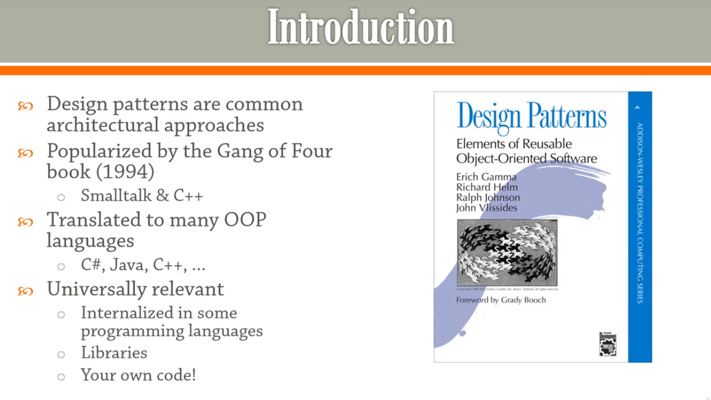

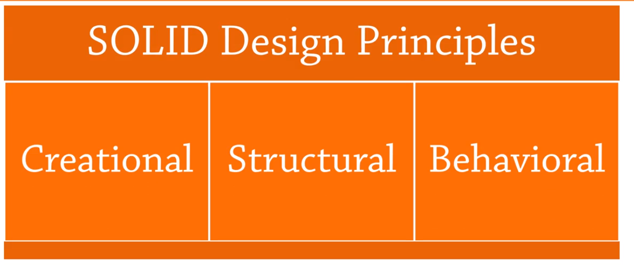

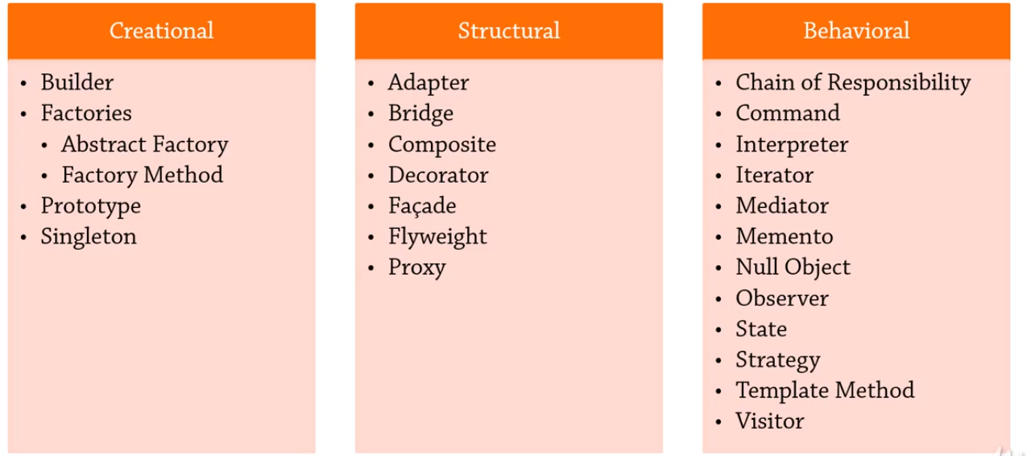

## SOLID Design Patterns:

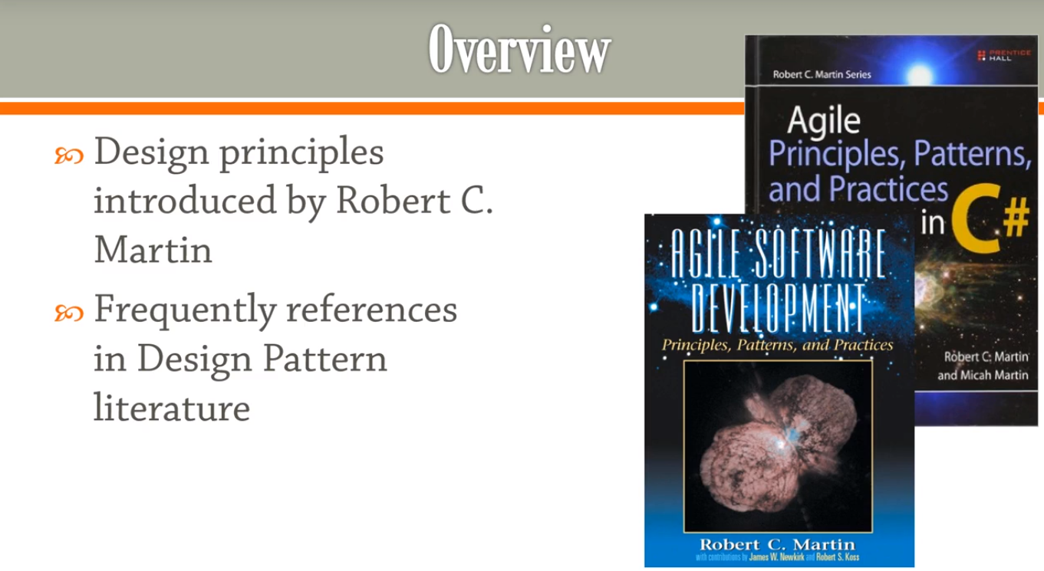

### Single Responsibility Principle:

Single class should have one primary responsibility.

There should be separation of concern , if multiple responsibilities are assigned to same class. A new class should be introduced. If we add more objects, it becomes more difficult to manage and refactor later on.

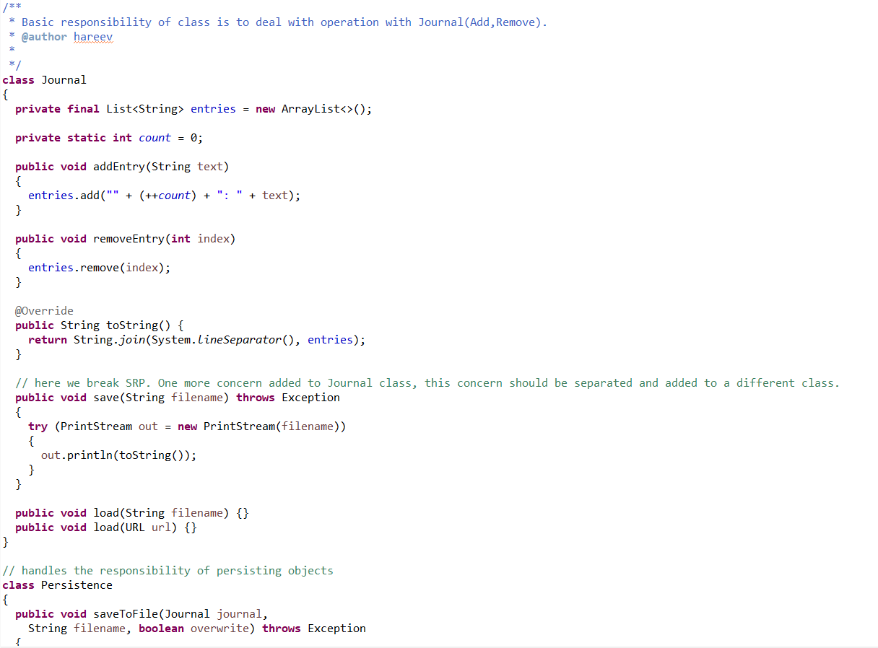

### Open-Closed Principle:

Open for Extension , Closed for Modification.

OCP + Specification(NOT a GoF Design Pattern) Design pattern is explained below.

Suppose we are implementing E-Commerce app and we need to allow users to filter the products based on different criteria.

In the below code, each time when a new criteria is introduced we keep on editing the tested code and add new filters. This actually breaks the OCP. For 2 criteria as below there are 3 methods, if we add one more criteria we need to have 7 methods for the total 3 criterias.

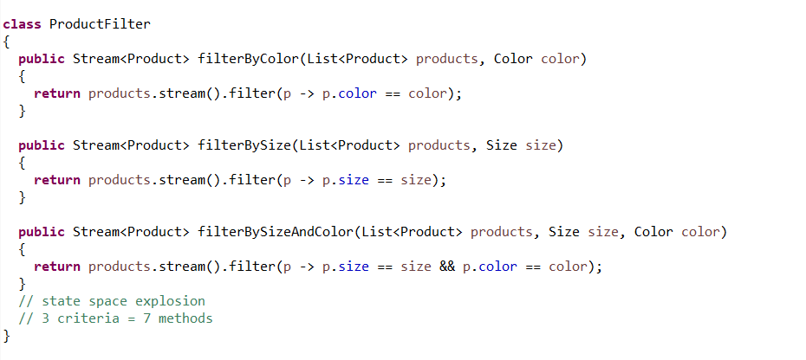

The above problem can be improved by using Specification Pattern.

* Introduce a new generic interface,Specification, which has method to check if a particular product satisfies a criteria.
* Introduce a new generic interface Filter , which filters the products based on the criteria.

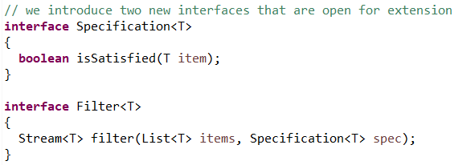

* Now build the specification, ex: ColorSpecification.

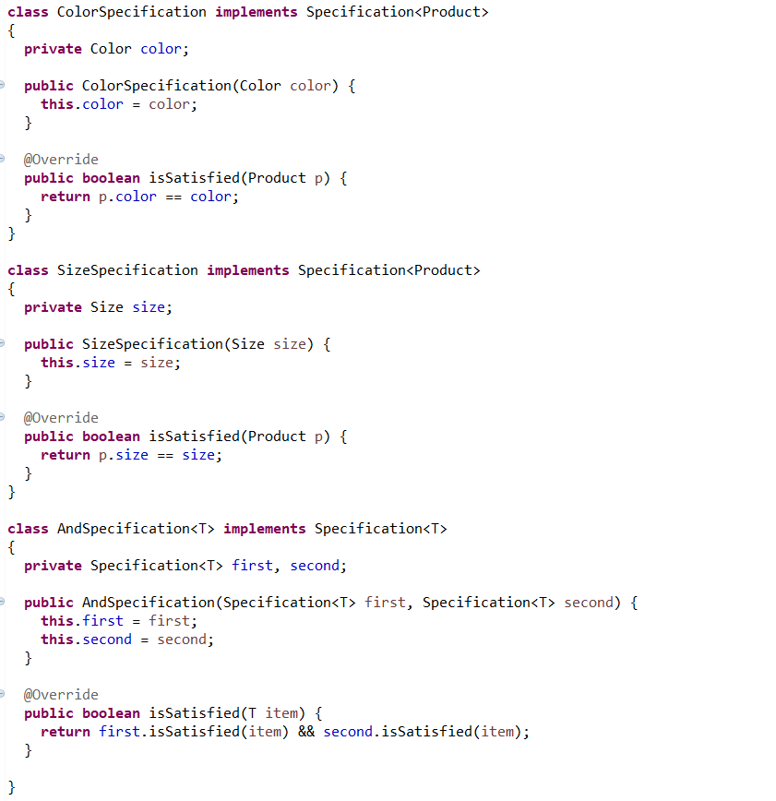

* Implement the Filter.

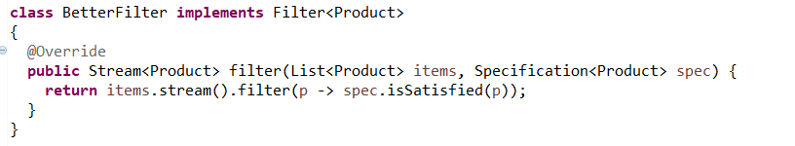

* Call the filter as below

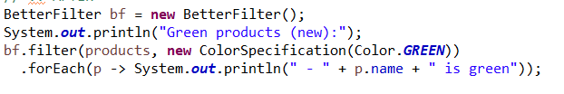

### Liskov’s Substitution Principle:

* Created by Liskov
* Idea is we should be able to substitute a sub-class for a base class.
* Ex: If there is an API which takes the base class, we should be able substitute the sub-class without breaking the code.

**How LSP is violated:**

If we are implementing square as a type of rectangle and there is a method called ‘area’.

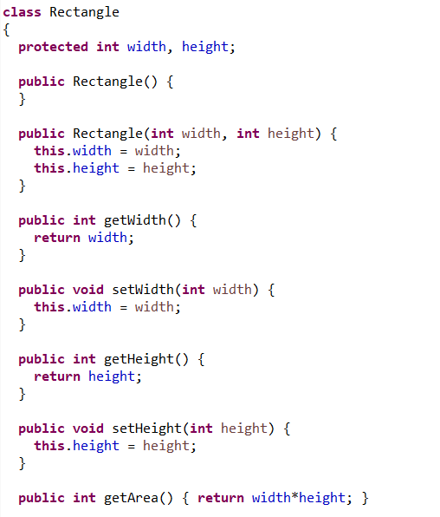

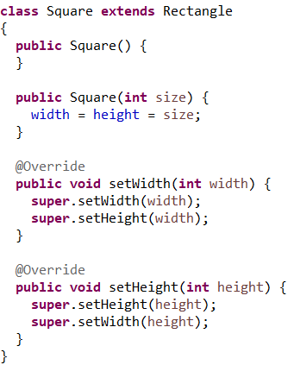

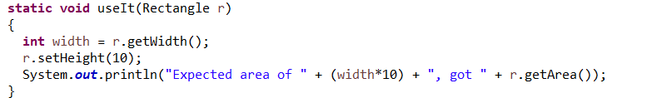

* In the above usage , we are expecting the, Area to be 10 times of provided width as we have substituted height as 10 .

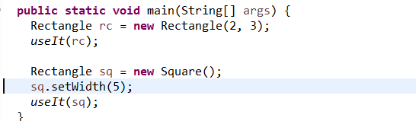

* But in above rc returns 20 but sq returns 100. So we violated the sub class can be substituted for base class principle, where square violated rectangle.

**So to idealise the situation, there is no need for a Square, but we can have a method which checks isSquare. Or we need to use Factory Pattern.**

### Interface Segregation Principle:

* This is basically a recommendation on how the interfaces can be split into smaller interfaces.
* So we should not put anything into our interface that the client doesn’t want. So as the word suggests segregation means putting apart or putting into separate categories.
* Instead of putting everything into one interface, make sure it is separated and the client should not implement any code that they don’t really need.
* Ex Scenario.  
  Let’s say we have a Document class. We have implemented an interface,’Printer’, to have operations on Document(Print,Fax,Scan). Suppose if we have an old client, which needs only one operation (say print), so the methods Fax,Scan will be empty for them.
  + We need to handle the scenario by leaving empty or adding NotSupported Exception.

So to fix the problem , divide into Printer,Scanner interfaces.

* If we need a photocopier, implement both Printer & Scanner interfaces.
* Also one interface can be made which extends multiple interfaces.
* YAGNI- You Ain’t Going to Need It.
* MultiFunctionMachine implemented below is an example of Decorator pattern.

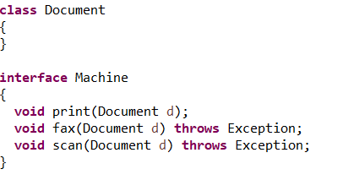

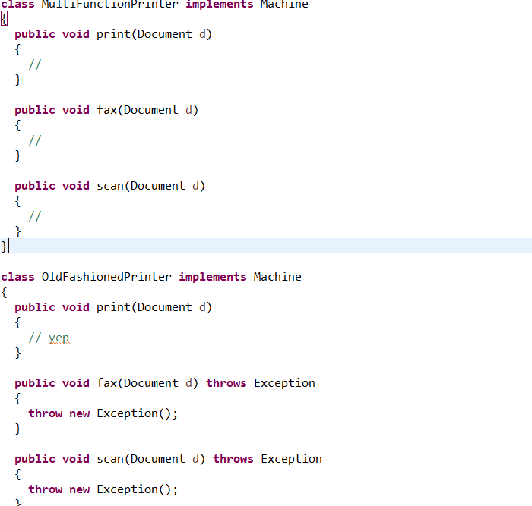

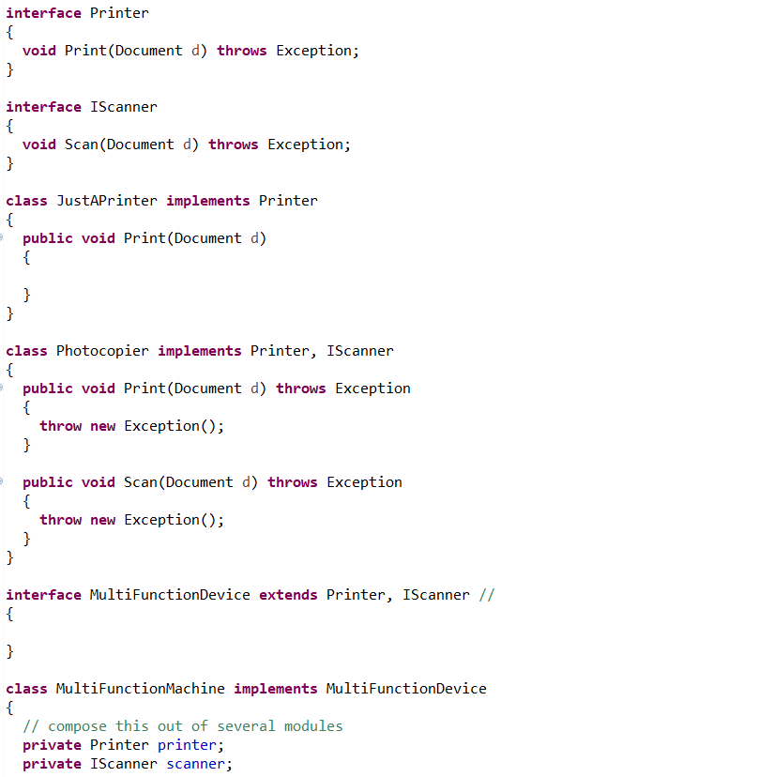

### Dependency Inversion Principle:

* It doesn’t directly connect to the idea of dependency injection although it is close.

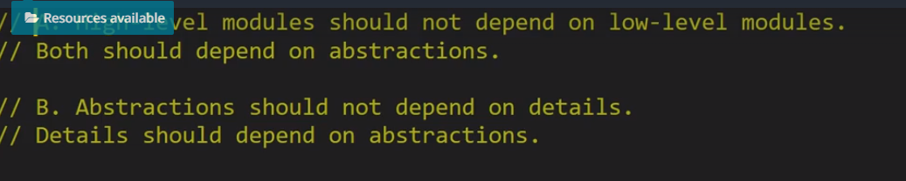

* Abstraction is either an abstract class or interface.
* Abstraction:-we get a signature but we don’t get a concrete implementation. SO basically it means to use interface/abstract class instead of concrete implementations.

Sample scenario to represent the #1 point above(High level modules should not depend on low level modules) is given below:

* Think of a family tree and we need to model the relationship between people.
* We are adding a relationship using triplet .

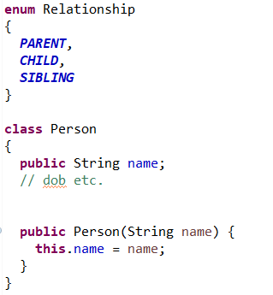

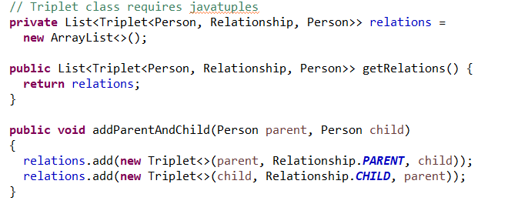

* To make some research on people relationships we do the following.
  + Below to fetch the children of Parent(John).High Level

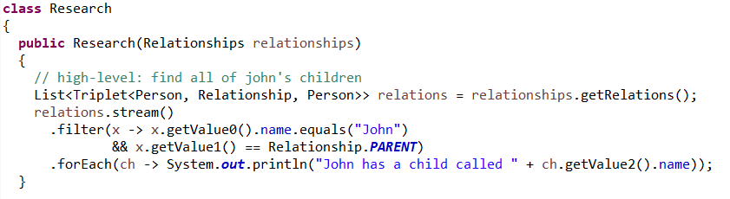

* The problem with above code is we are exposing the internal relationships as a public getter, which is too bad design.
* In the above case, relationships is a low level module as it’s directly related to data storage.
* Research is a High Level module as it carries out some operation.
* So in our case, constructor of HighLevelModule(Research) takes in a low level module(Relationship). This needs to be changed.

They should depend on abstractions.

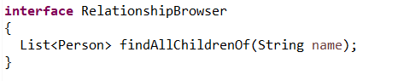



* We have made Research to depend on RelationshipBrowser

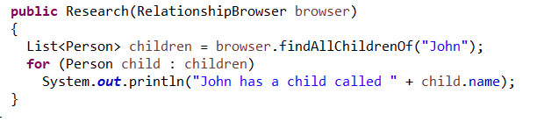

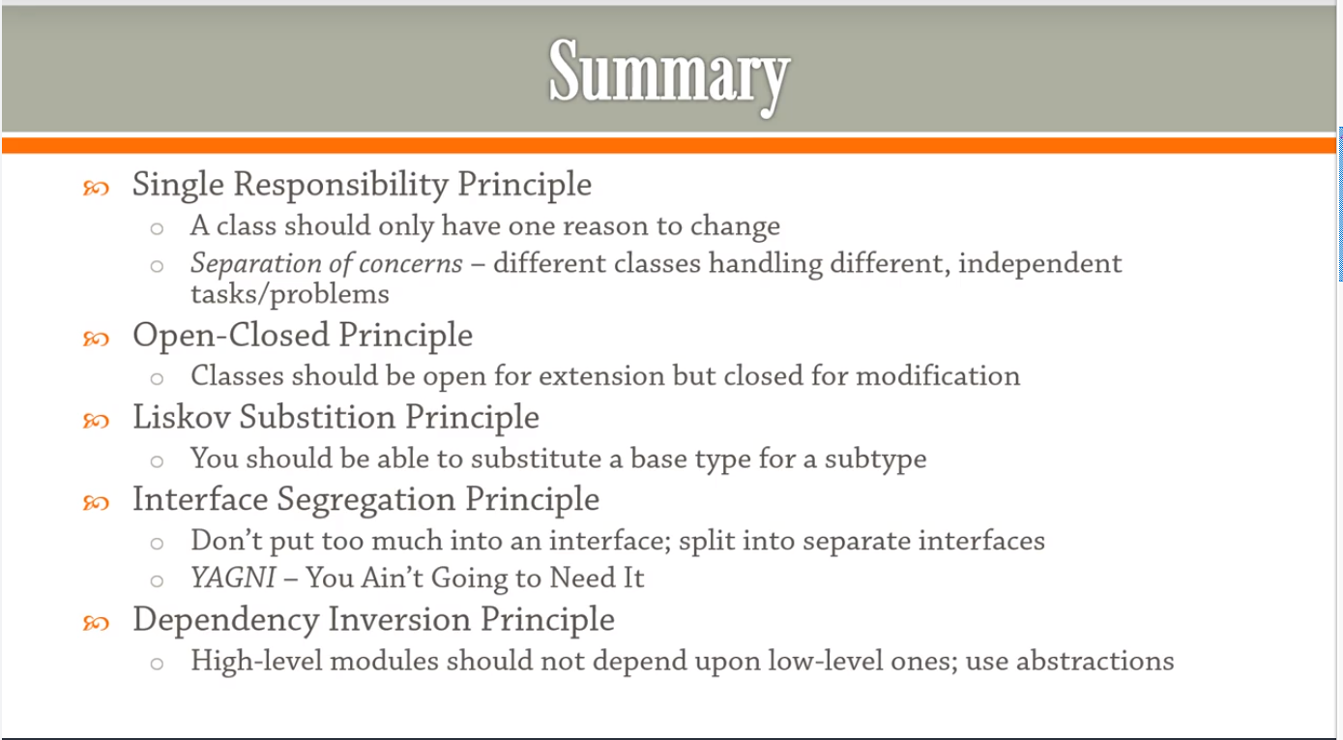

## Creational Design Patterns:

### Builder:

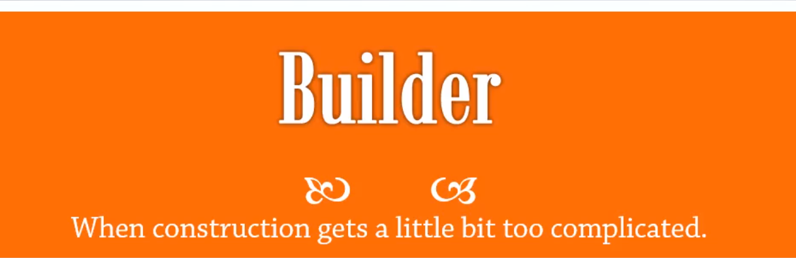

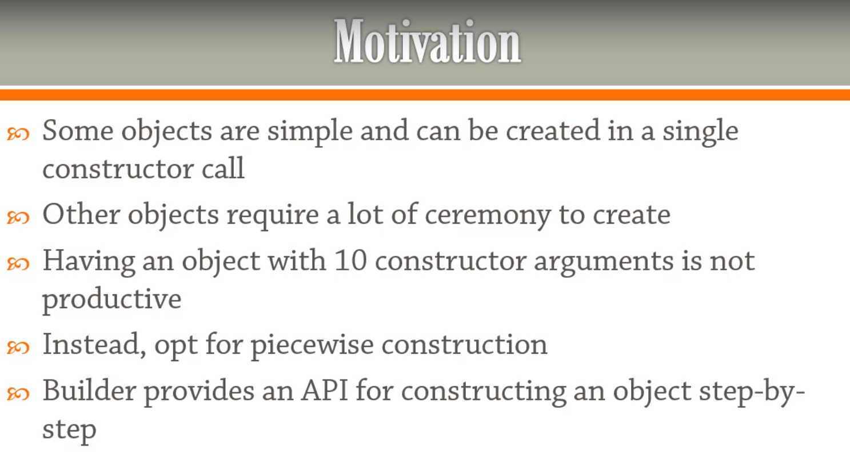

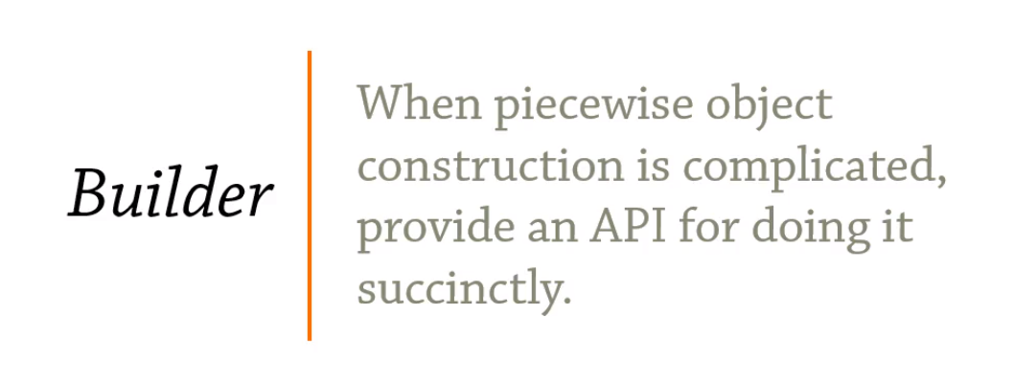

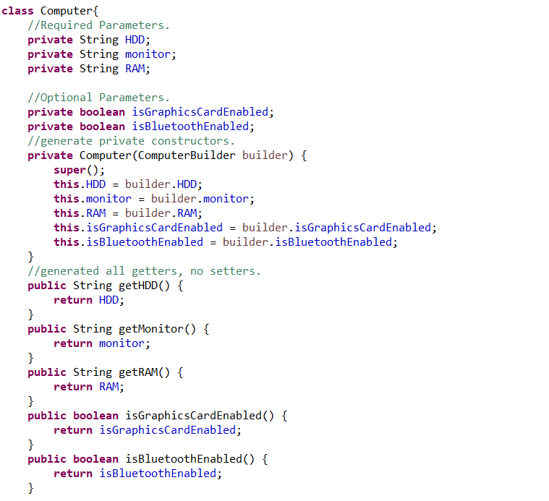

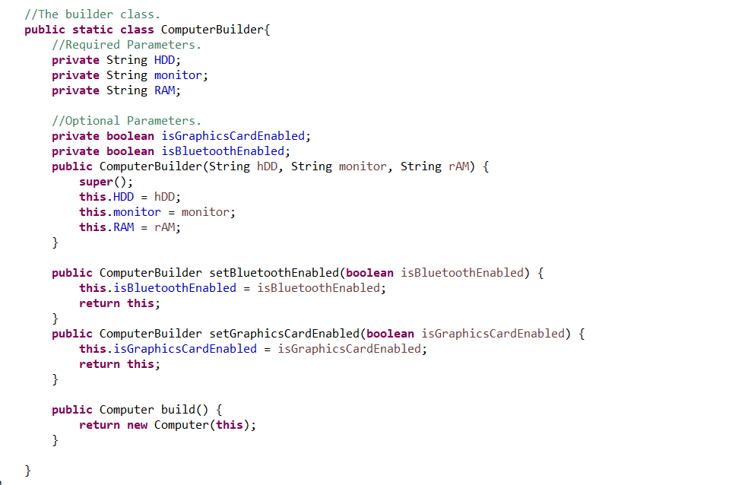

The class contains only getters, no setters and a private constructor which accepts the Builder class. The builder is a static inner class with setters and a Build() .

Computer computer = **new** Computer.ComputerBuilder("hdd", "monitor", "ram").setBluetoothEnabled(**true**).build();

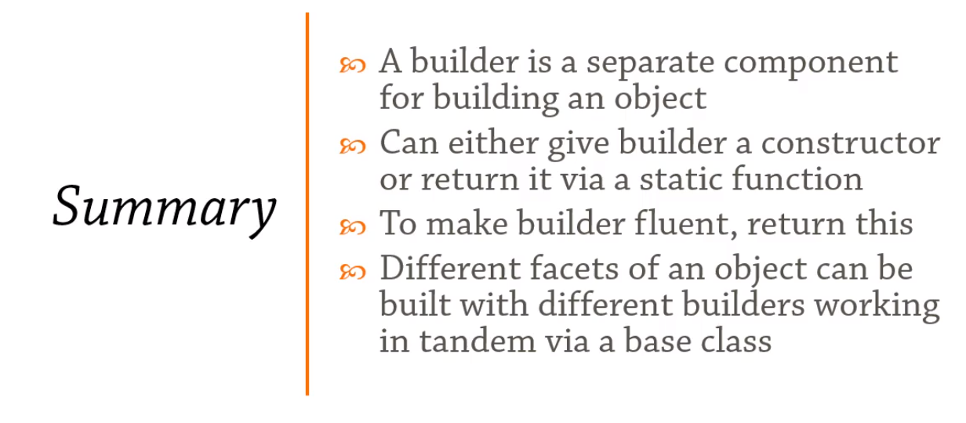

### Factories:

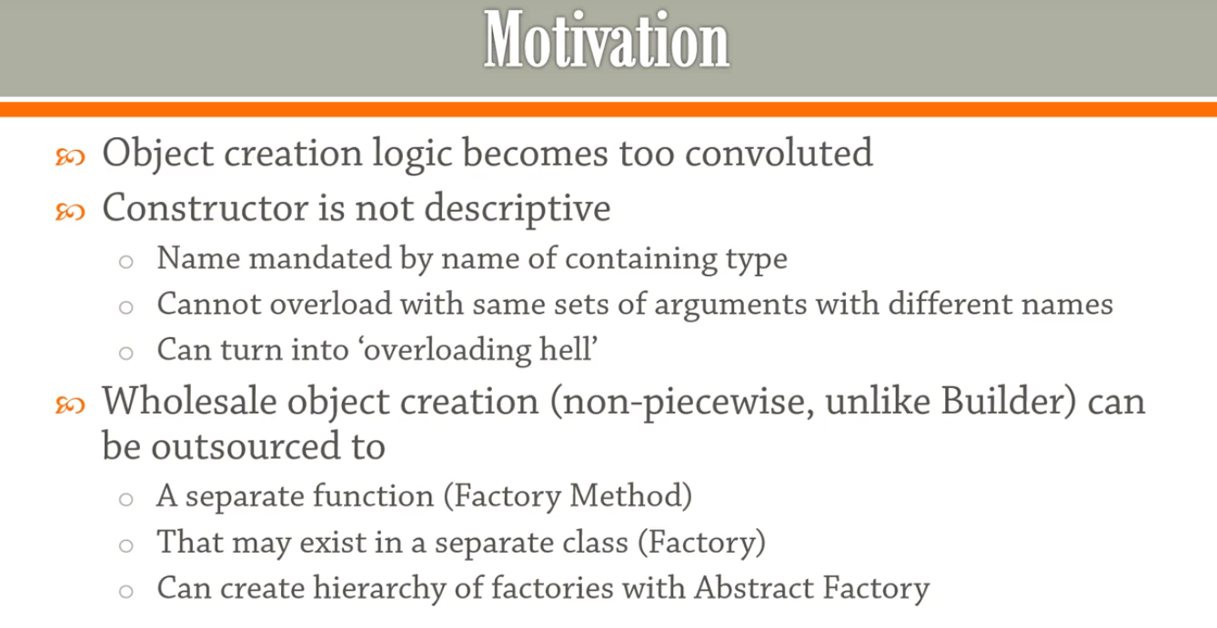

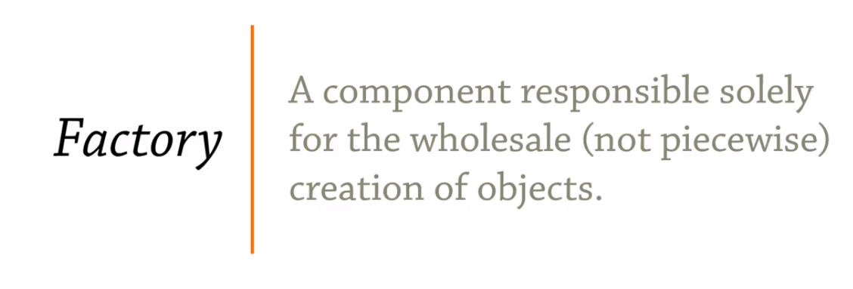

#### Factory:

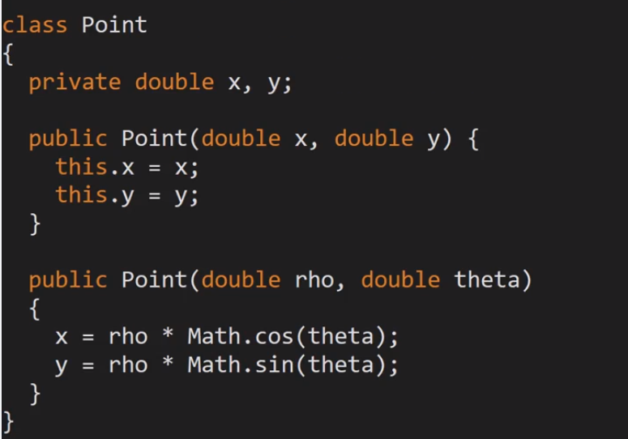

Above is not possible in java, overloading with variable names.

So we might need to introduce an Enum to define the coordinate system and build the constructor based on the coordinate system.

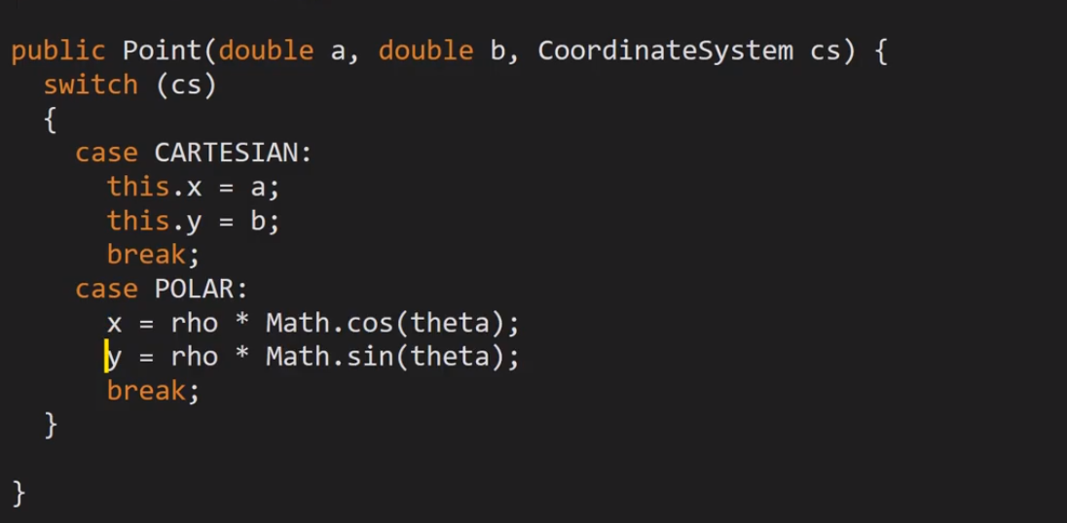

This makes the constructor more confusing. Factory Pattern solves this problem.

1. Makes the constructor private, so will force the client to make the object through factory only.
2. Write the desired static factory methods.

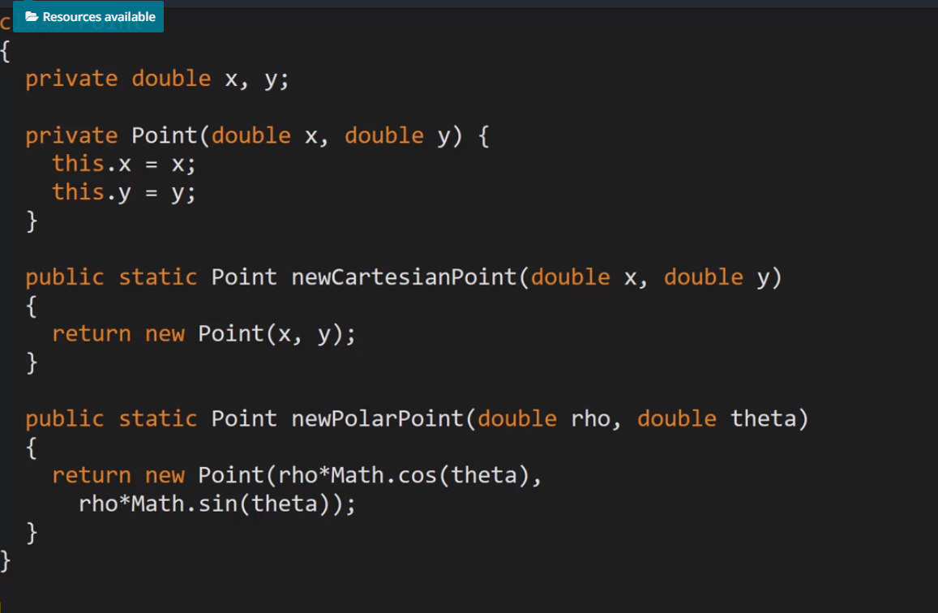

Point point = Point.newPolarPoint(2,3);

1. Factory pattern, wants the above logic to be moved to a factory class.

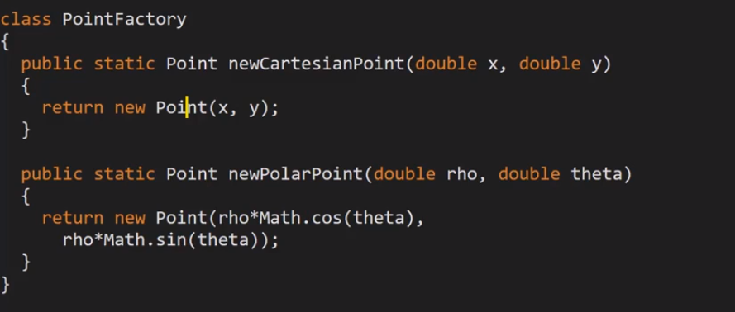

As we introduced a new class, the private constructor cannot be used, so the object can be created separate also. Otherwise we need to move the Factory class to inside of the class.

#### Abstract Factory:

This method is like a factory of factories. This eliminates the need for if-else statements and introduce factory as return.

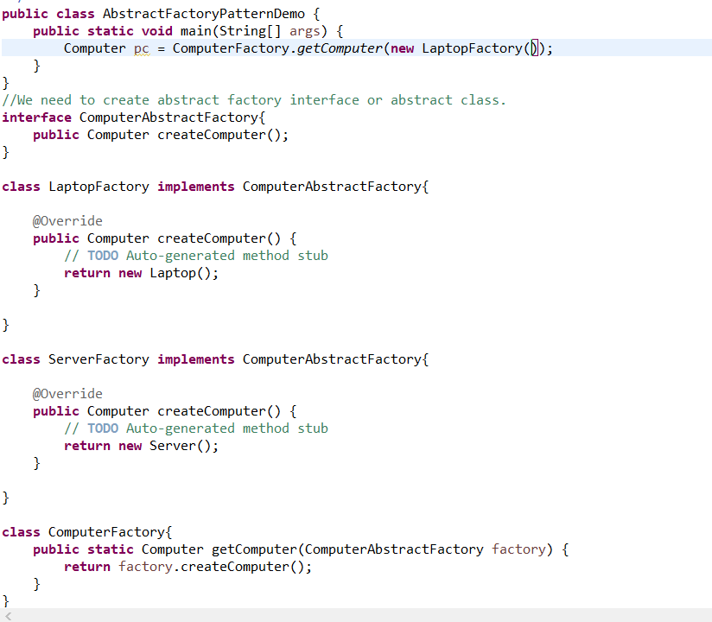

An abstract factory is introduced which is the parameter for the factory method.

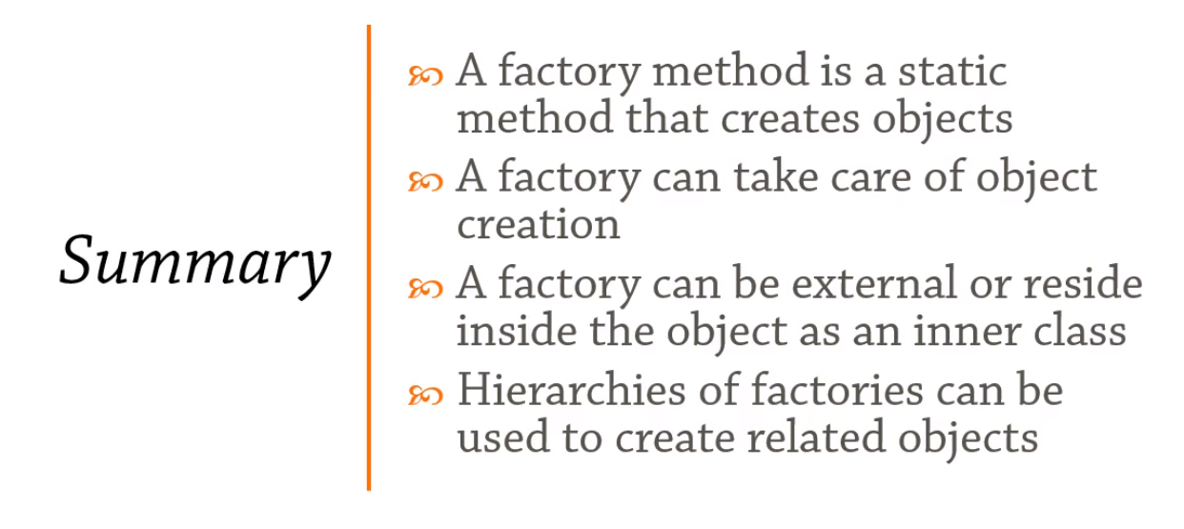

### Singleton:

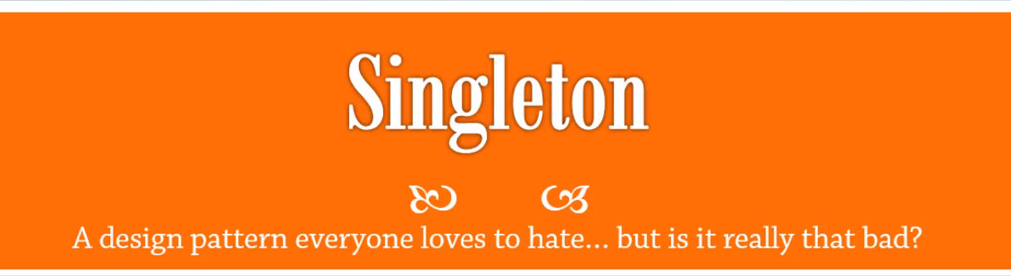

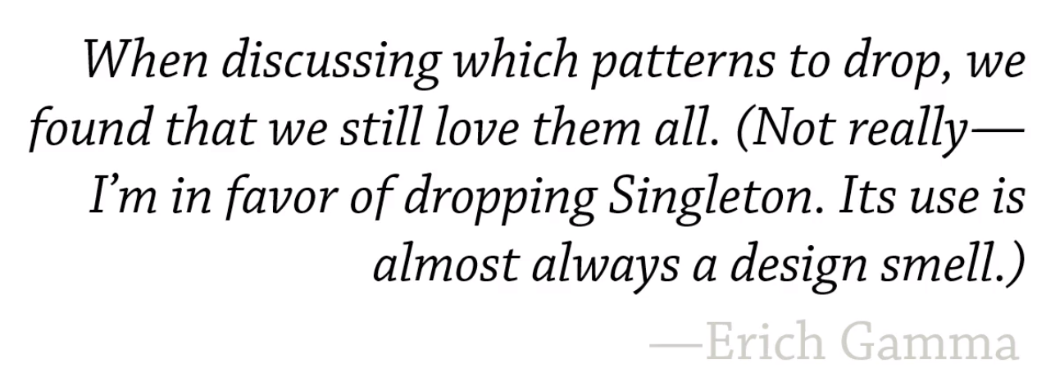

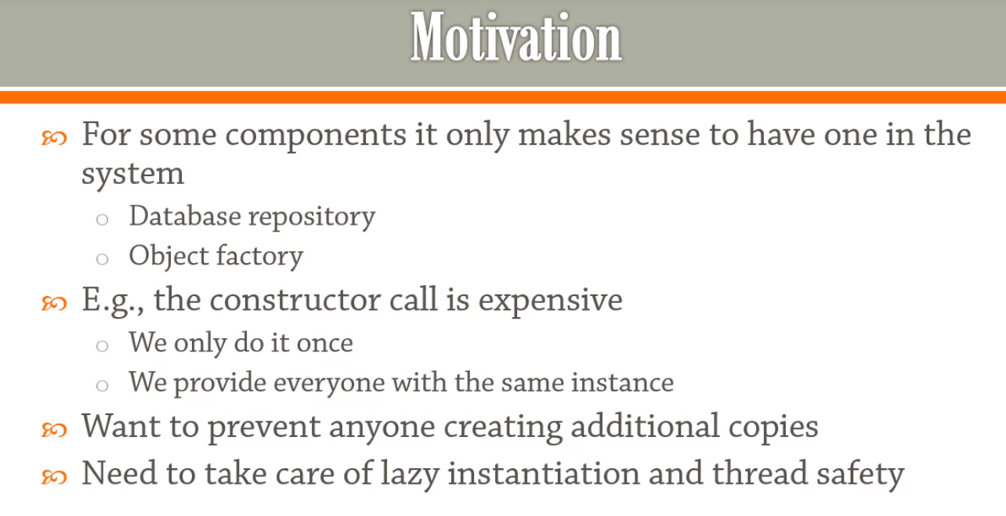

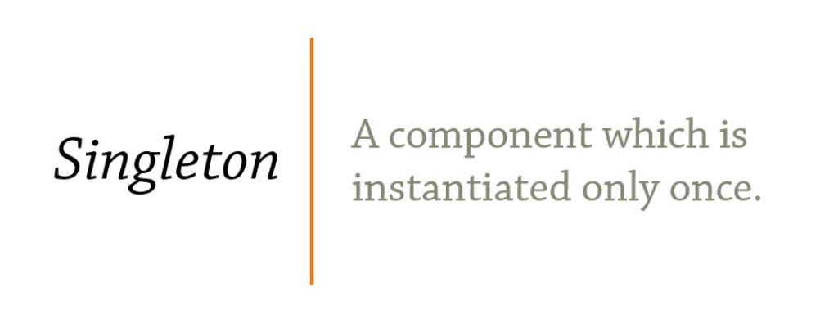

Serialization Problems with Singleton:

When we serialize and de-serialize we end up creating two different instances. This can be solved with **readResolve()**.

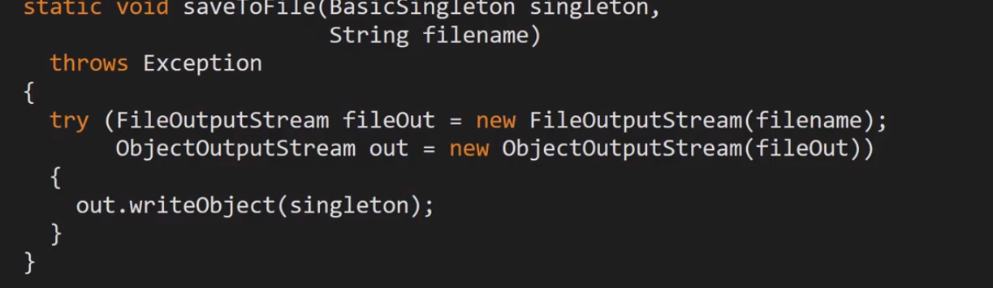

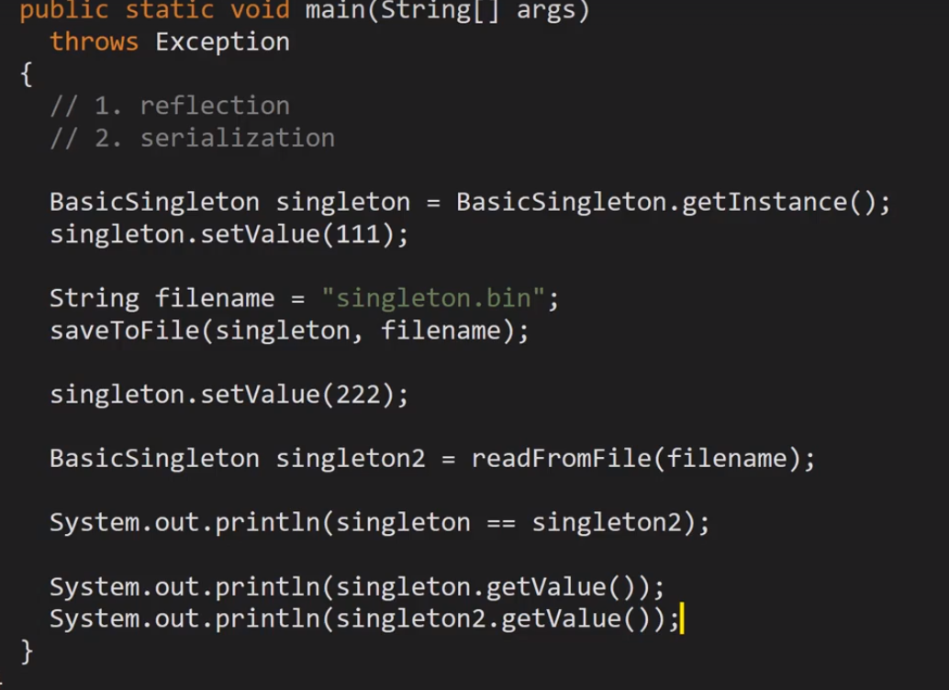

Lazy Initialization:

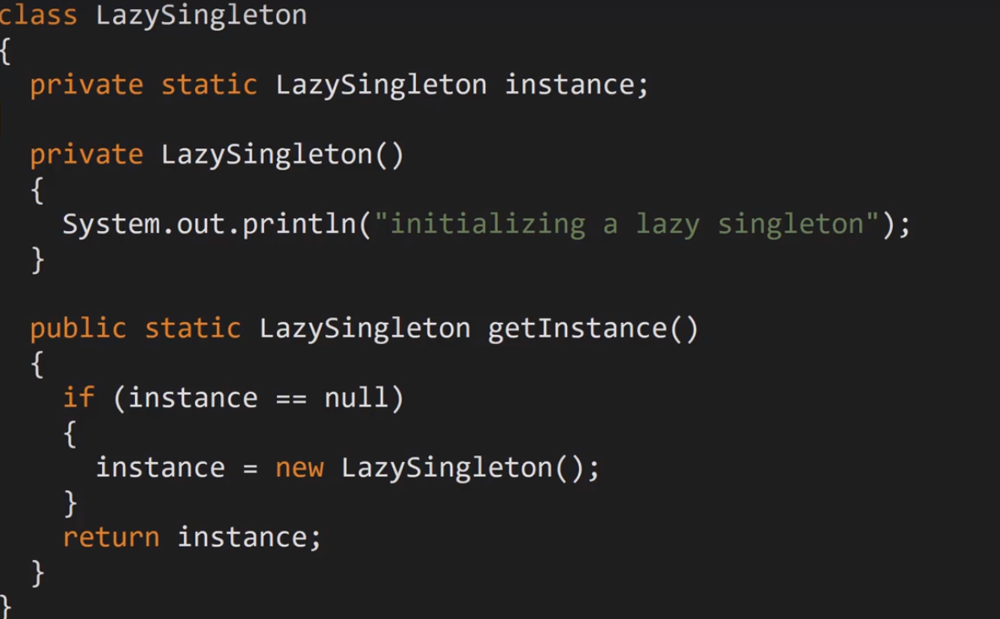

Thread safety can be achieved by synchronized method or on block of code by double check locking.

Inner Static Singleton:

This method eliminates the need for synchronized.  
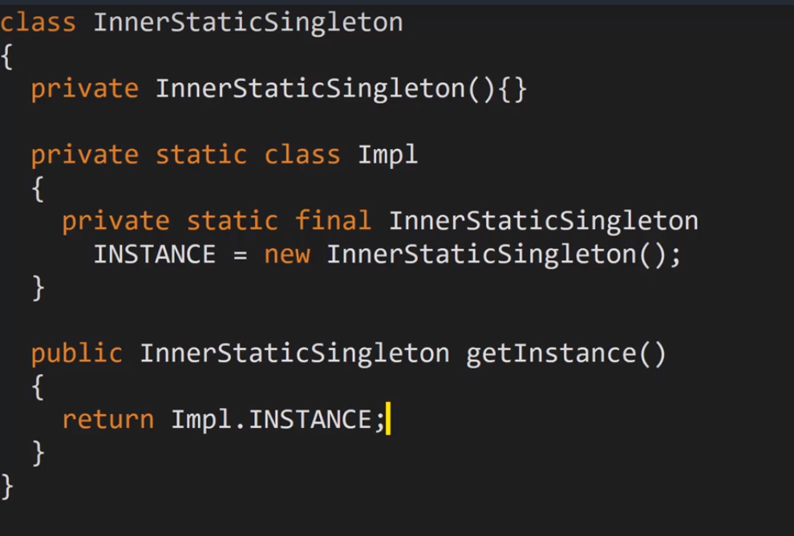

Enum Based Singleton:

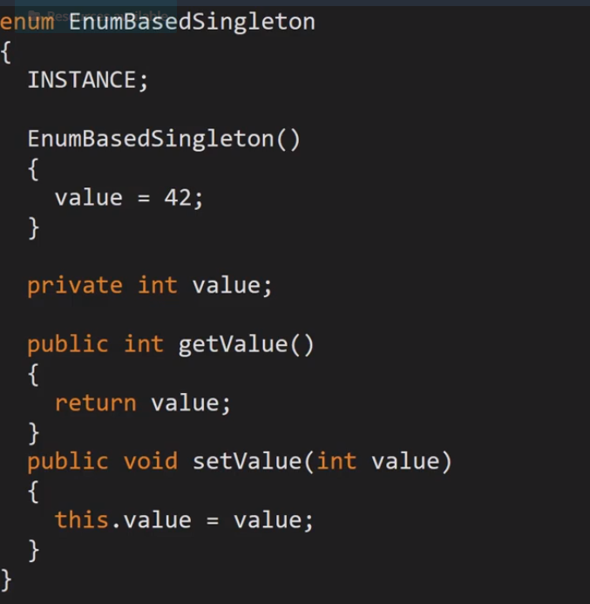

EnumBasedSingleton singleton = EnumBasedSingleton

.INSTANCE;

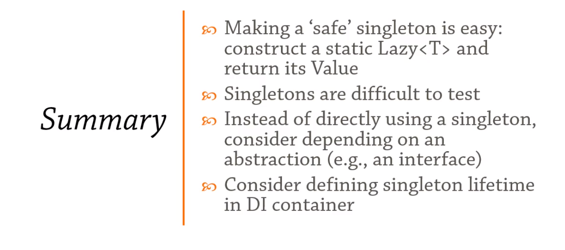

### Prototype:

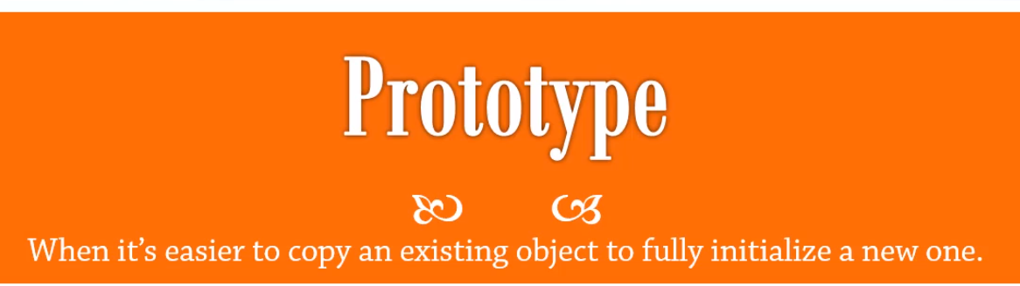

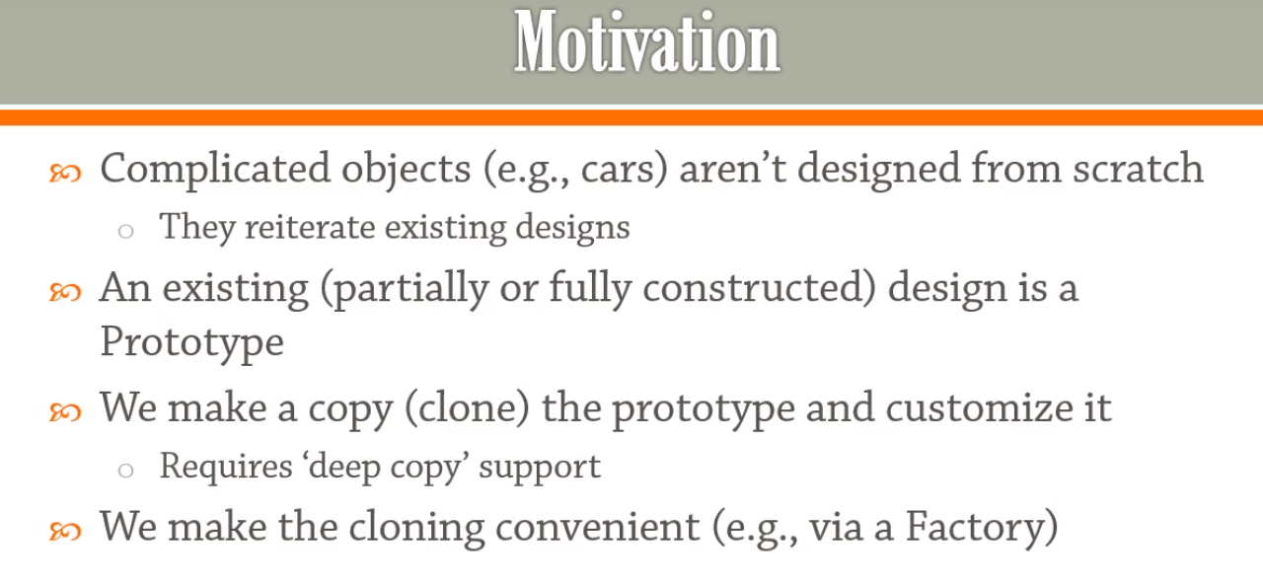

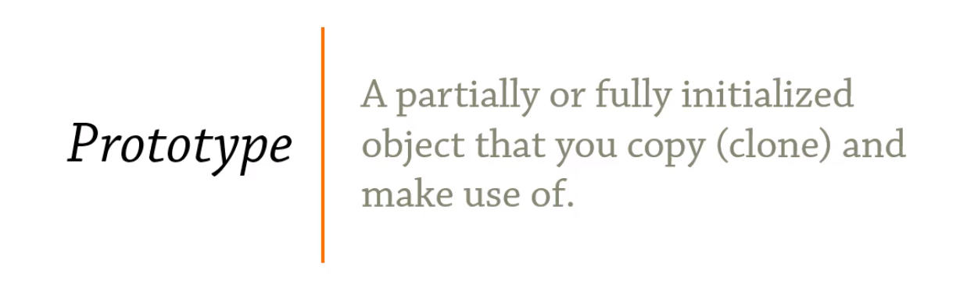

Prototype pattern provides a mechanism to copy the original object to a new object and then modify it according to our needs. Prototype design pattern uses java cloning to copy the object.

Ex: Suppose we have an Object that loads data from database. Now we need to modify this data in our program multiple times, so it’s not a good idea to create the Object using new keyword and load all the data again from database.

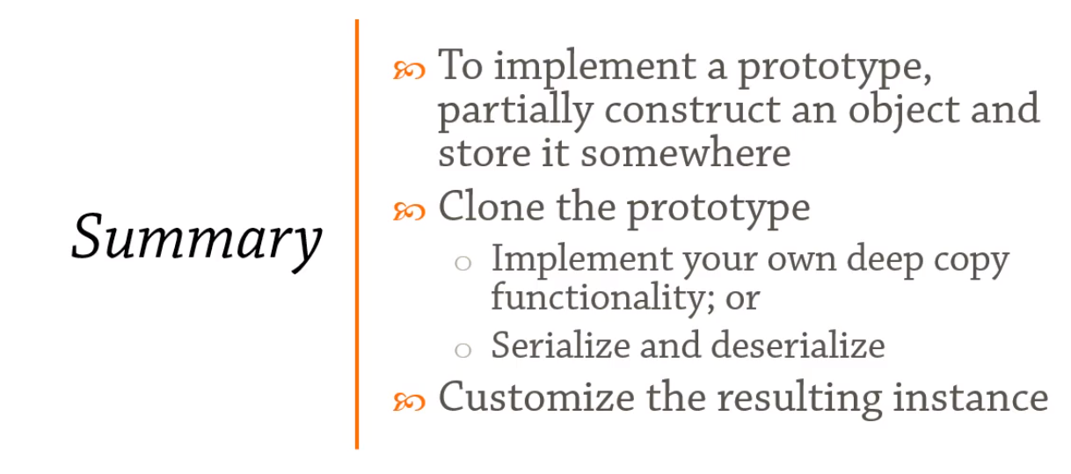

## Structural Design Patterns:

### Adapter:

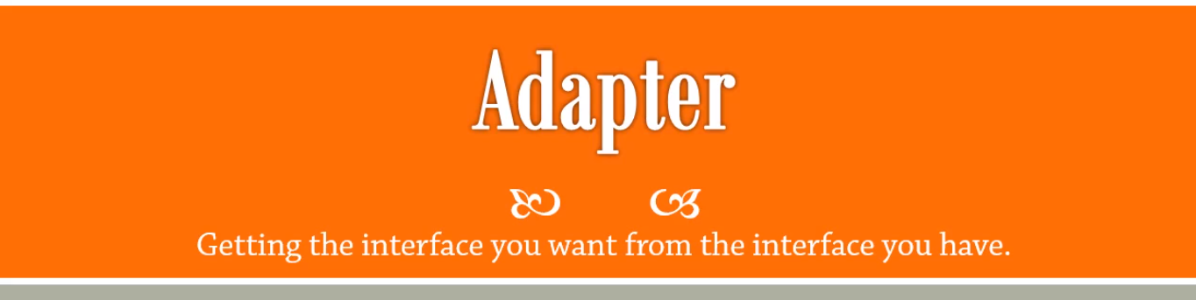

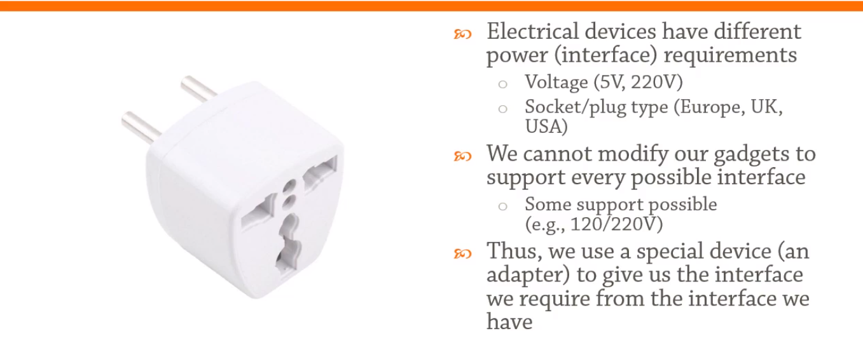

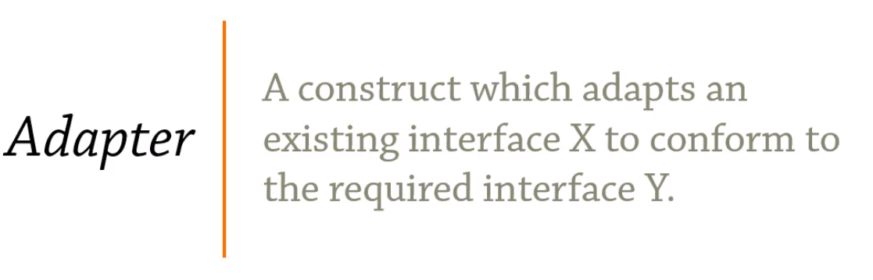

* Scenario: The best example of adapter design pattern is mobile charger adapter. Mobile battery needs 3V to charge but sockets produce 120v, so mobile charger works as an adapter between mobile charging unit and wall socket. *This ex is out of video.*

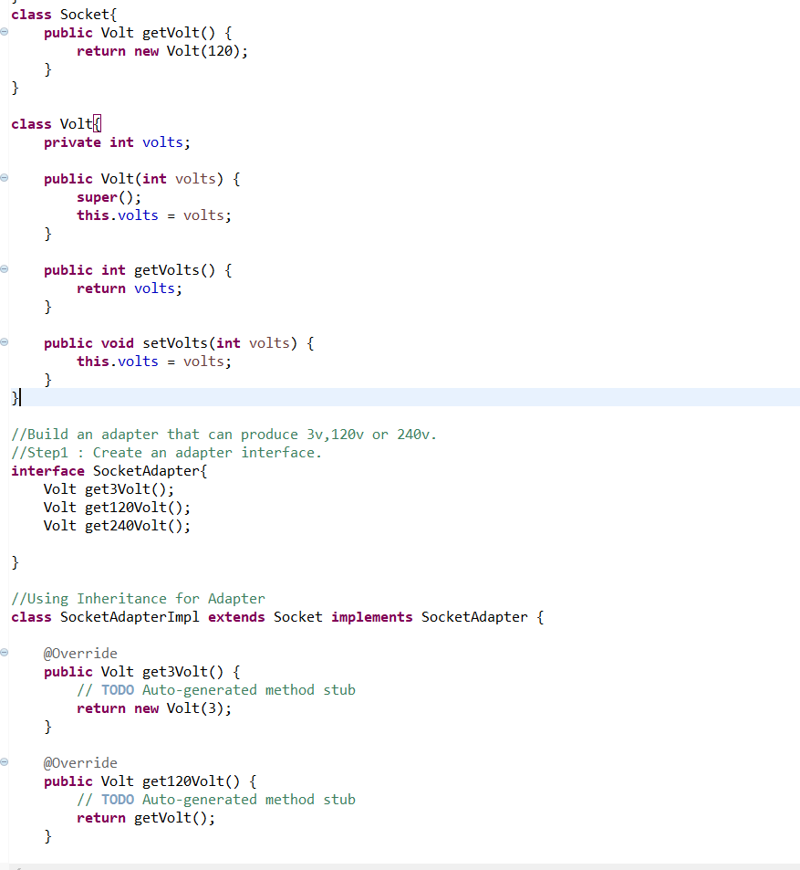

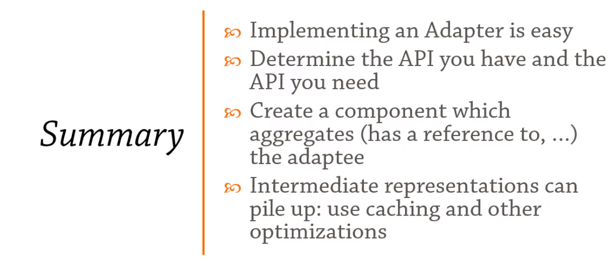

### Decorator:

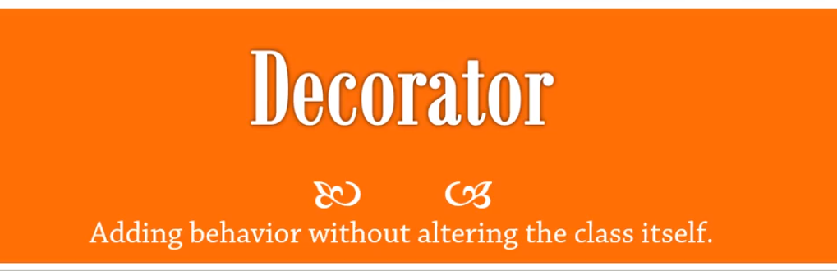

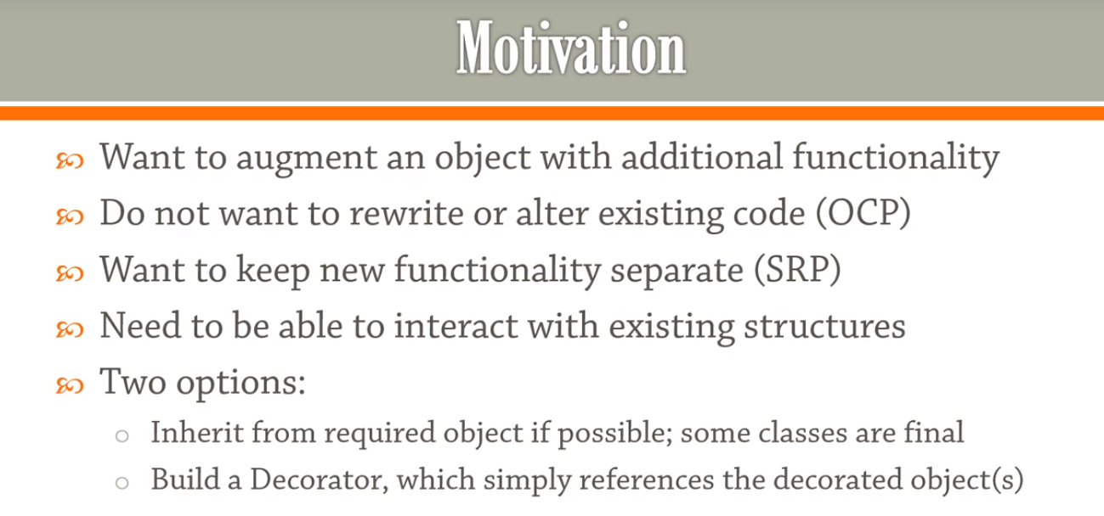

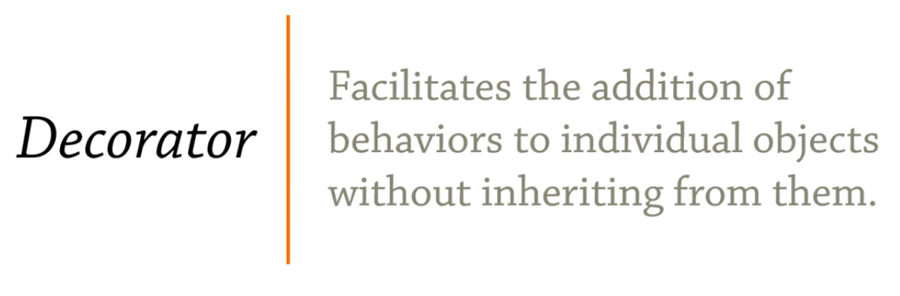

* We use [inheritance](https://www.journaldev.com/644/inheritance-java-example) or composition to extend the behaviour of an object but this is done at compile time and it’s applicable to all the instances of the class. We can’t add any new functionality of remove any existing behaviour at runtime – this is when Decorator pattern comes into picture.

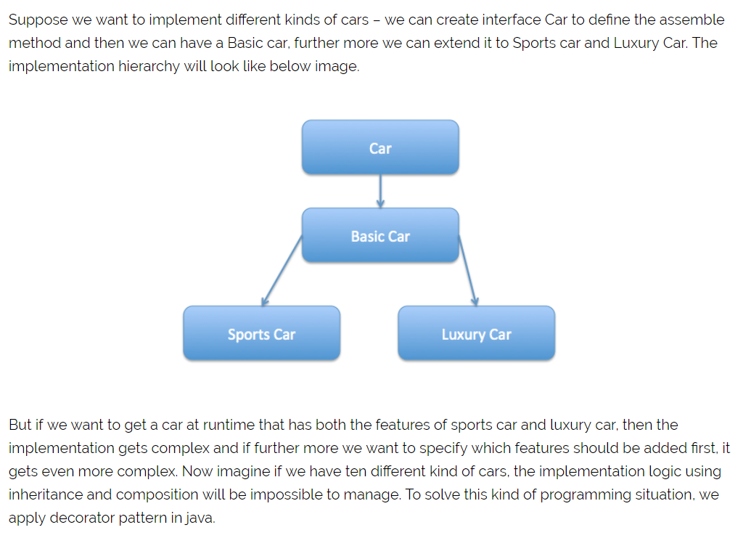

* **Decorator** – Decorator class implements the component interface and it has a HAS-A relationship with the component interface. The component variable should be accessible to the child decorator classes, so we will make this variable protected.

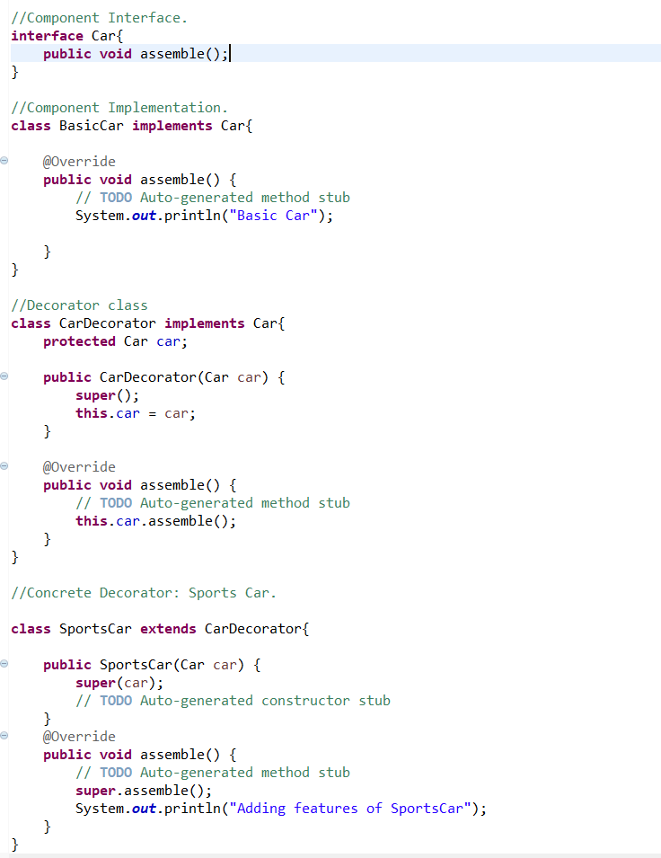

Car sportsLuxuryCar = **new** SportsCar(**new** LuxuryCar(**new** BasicCar()));

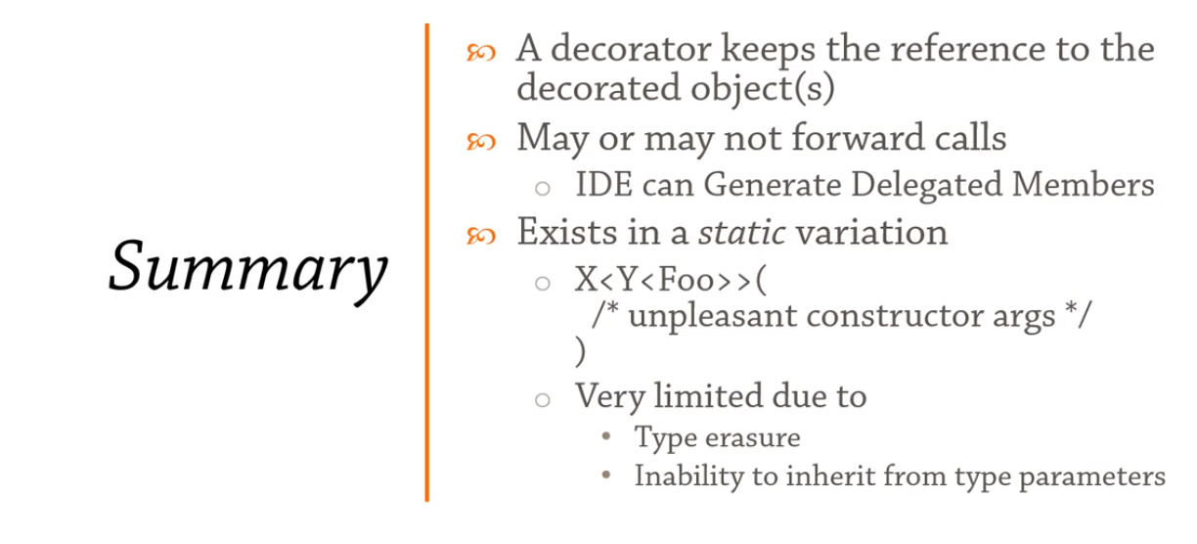

### Facade:

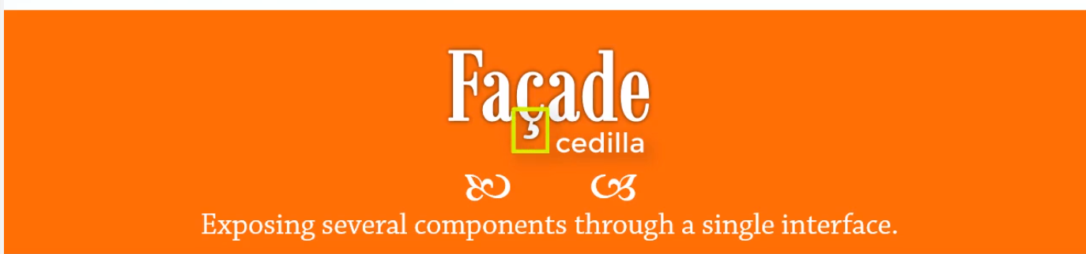

Cedilla make it pronounce as S instead of C. So it is Fasade design pattern.

Scenario: When we are buying a house we will look into how useful the house is and how presentable it is.

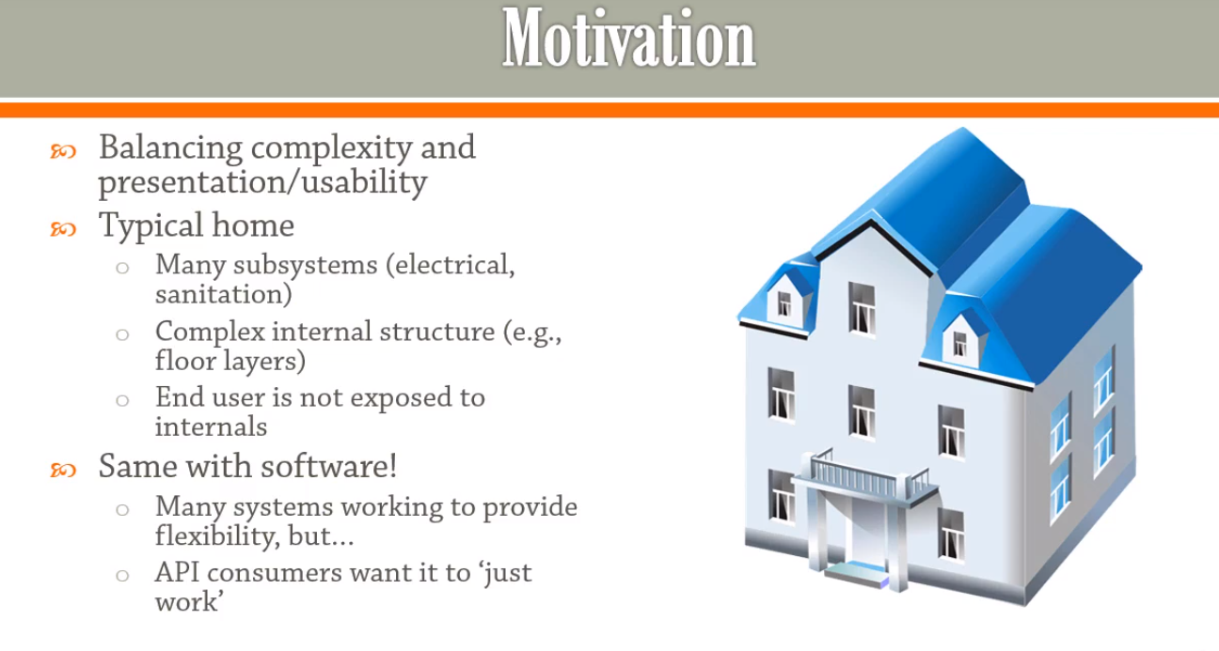

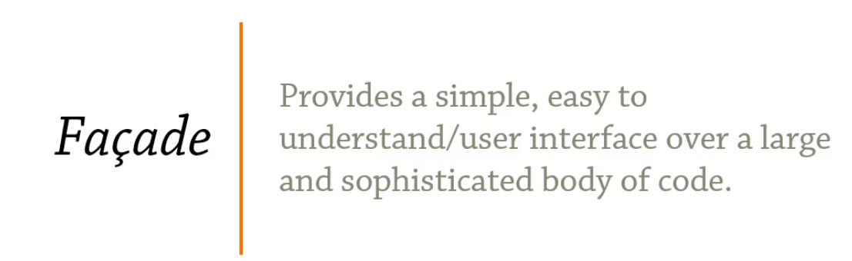

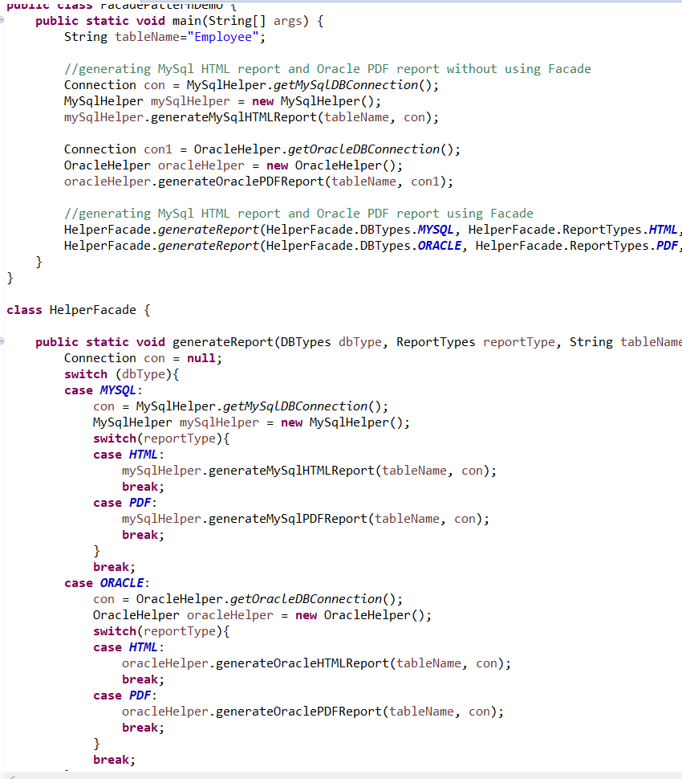

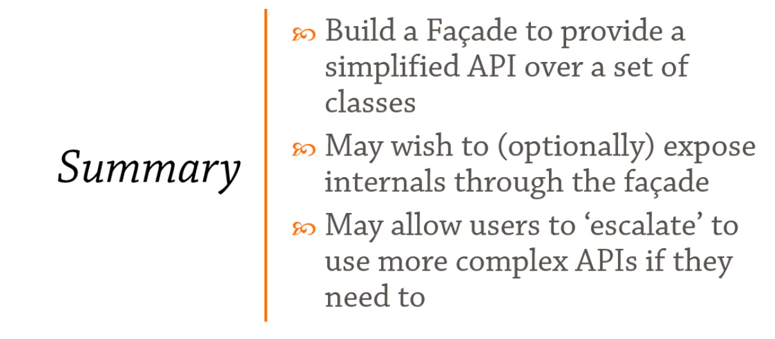

### Proxy:

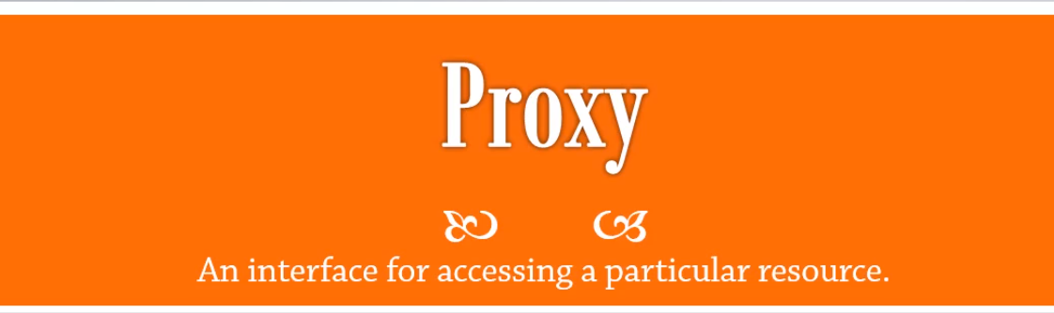

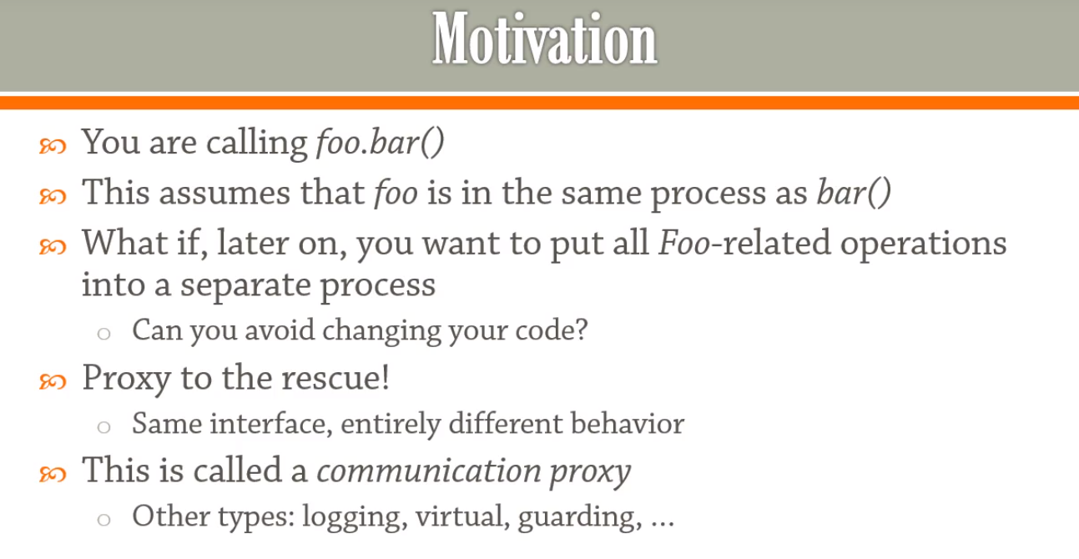

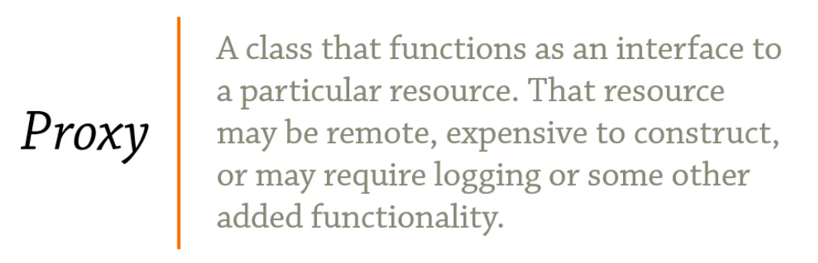

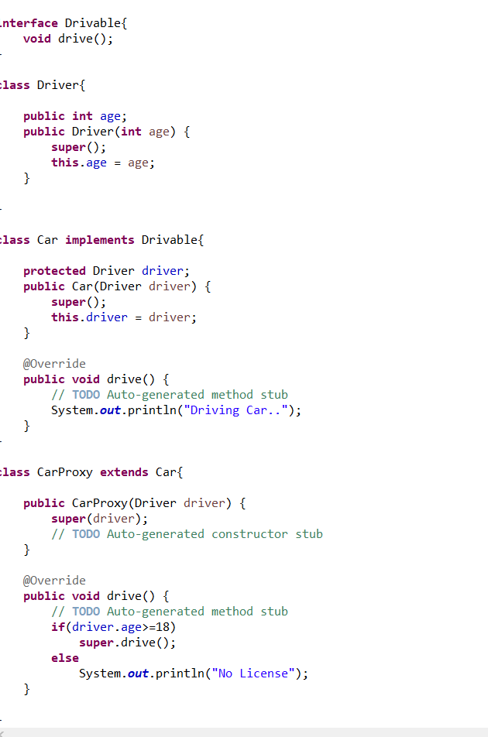

Car car = **new** Car(**new** Driver(12));

car.drive();

System.***out***.println();

Car car1 = **new** CarProxy(**new** Driver(12));

car1.drive();

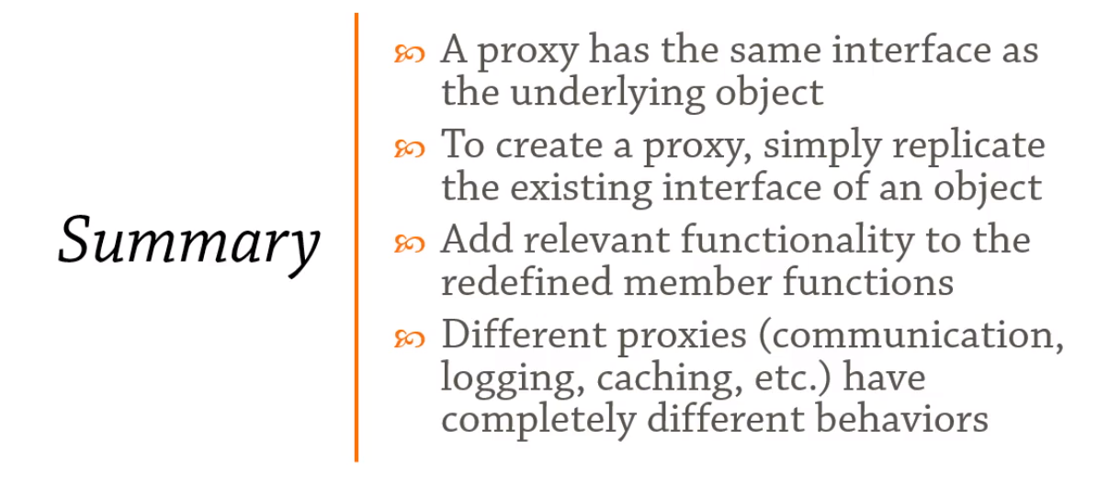

## Behavioural Design Patterns:

### Chain of Responsibility:

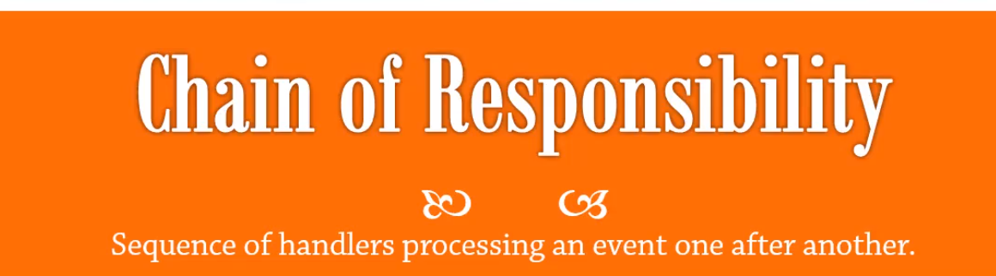

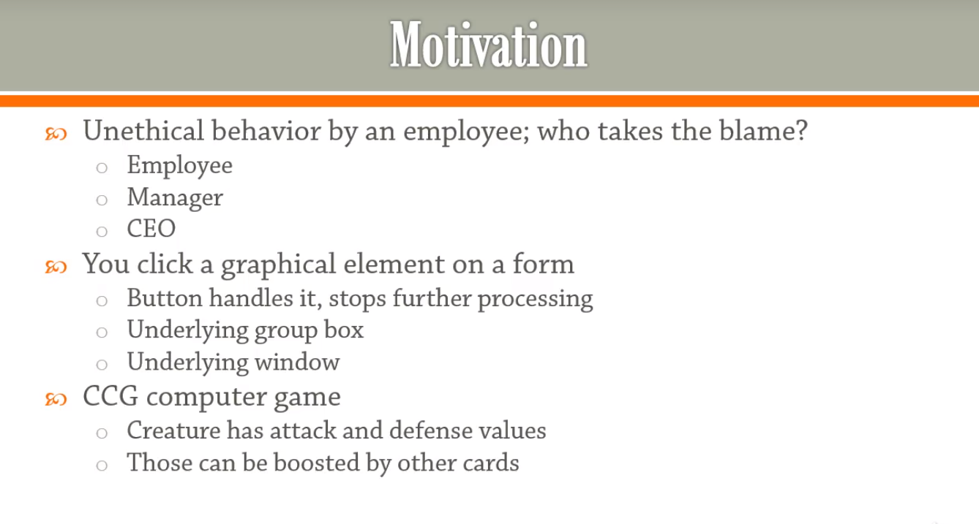

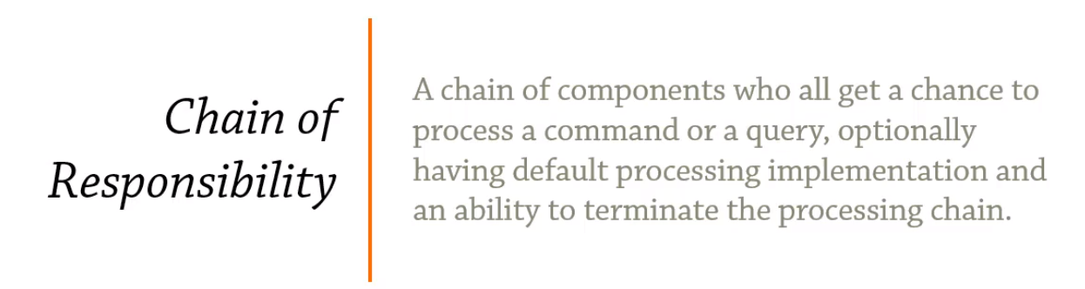

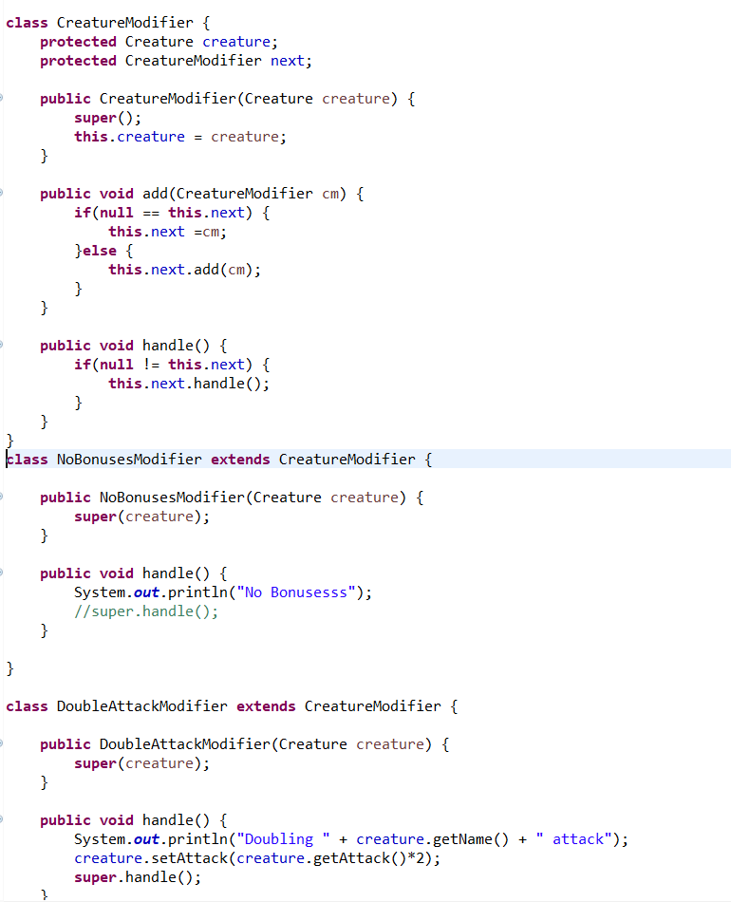

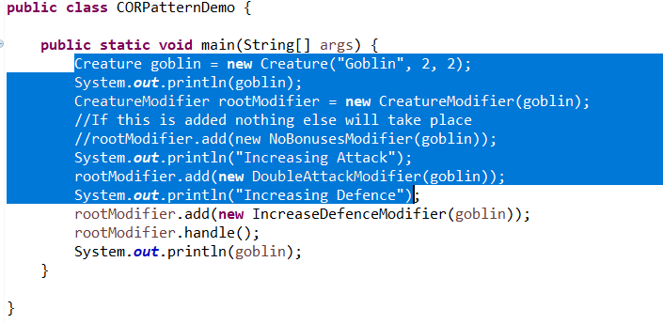

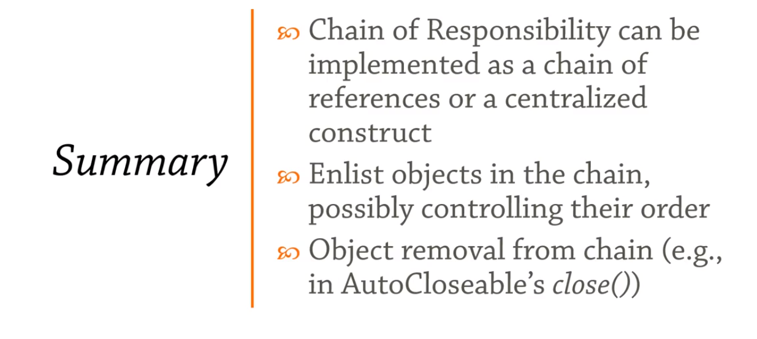

### Command:

* Encapsulate a command request as an object

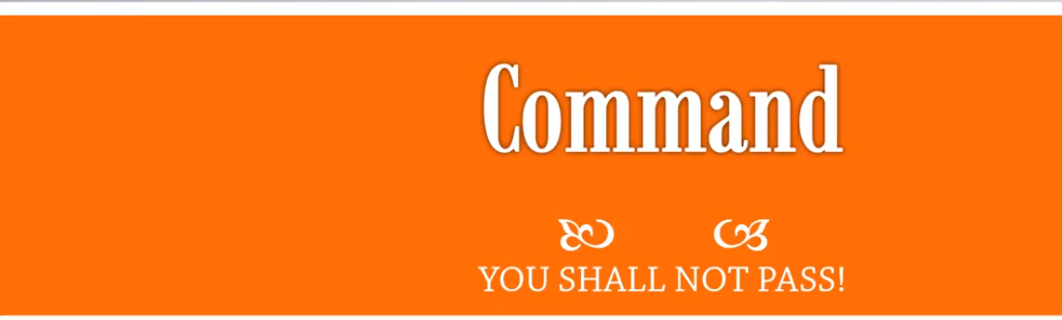

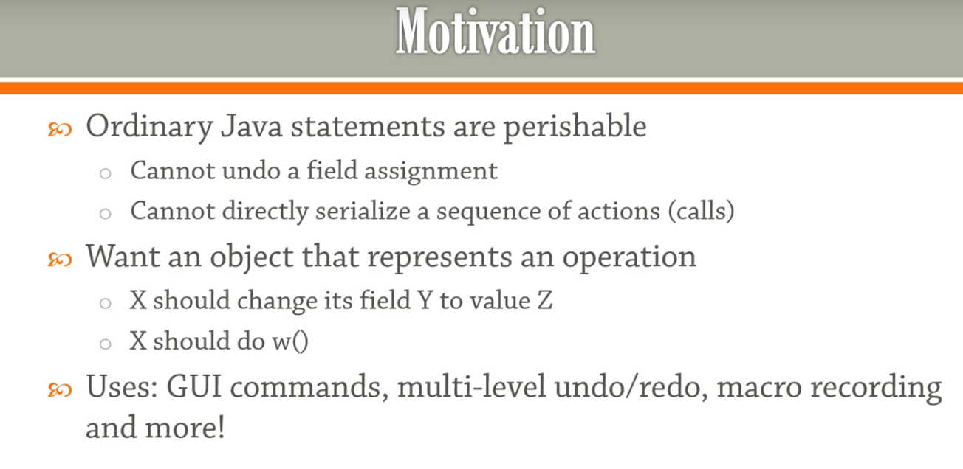

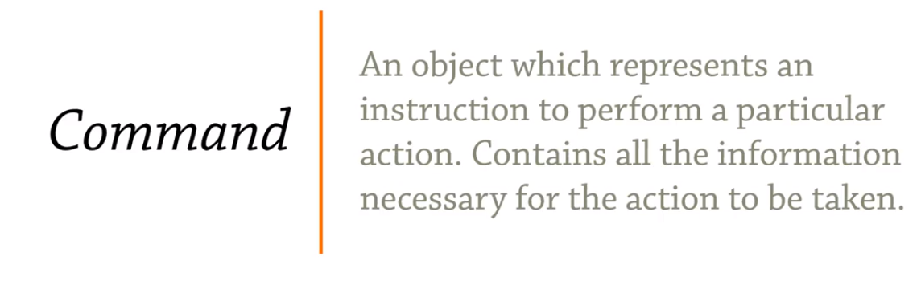

Example Scenario: BankAccount.

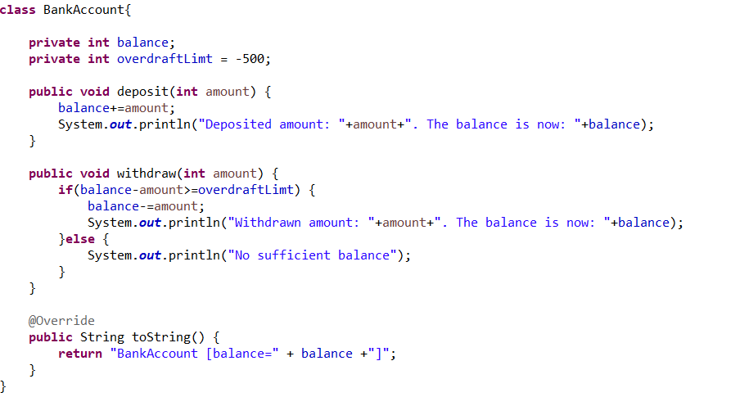

The BankAccount object has deposit and withdraw operations.

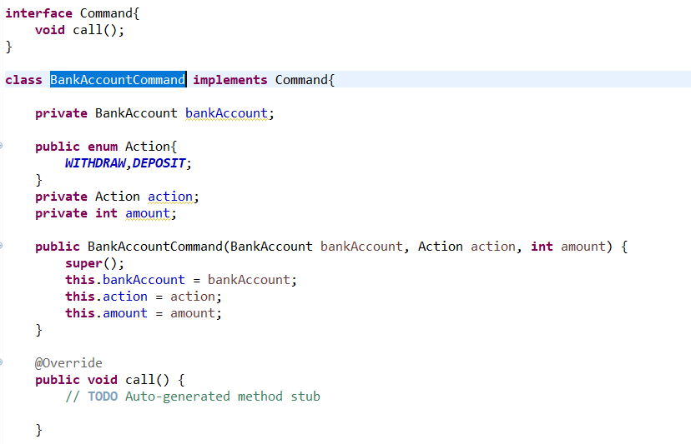

Now we need to implement the **call()** on **BankAccountCommand**.

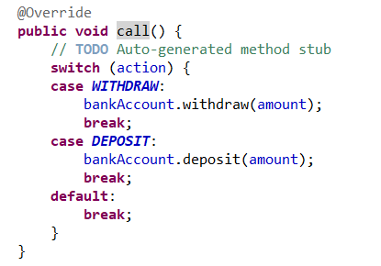

The interface is introduced if we need to Undo the commands.

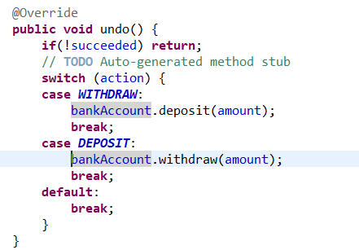

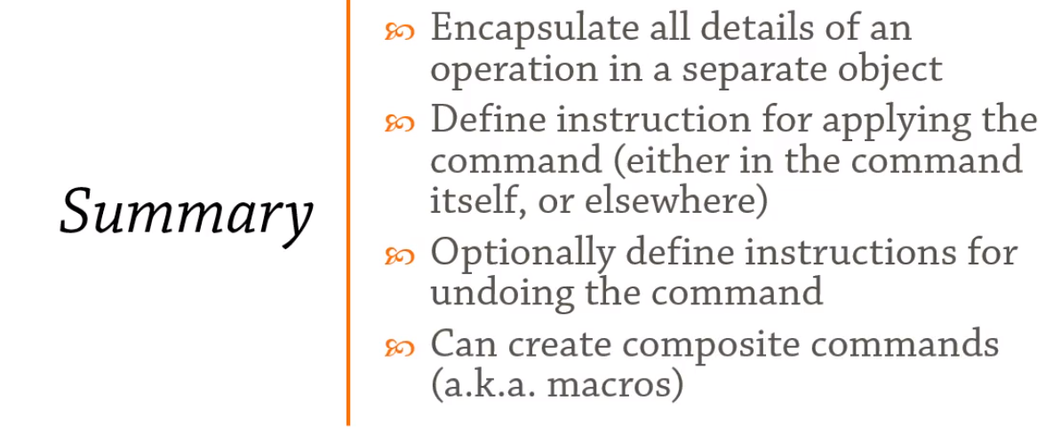

### Observer:

* A way of notifying change to a number of classes

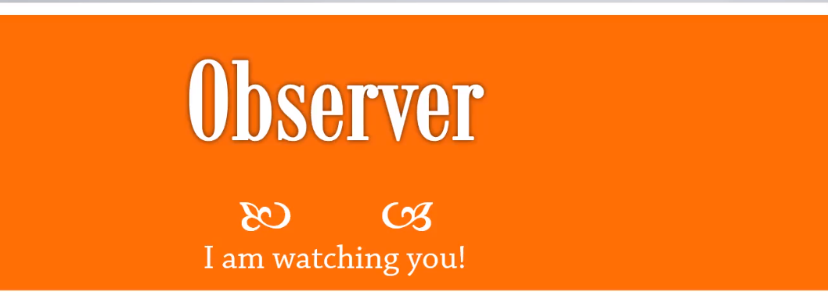

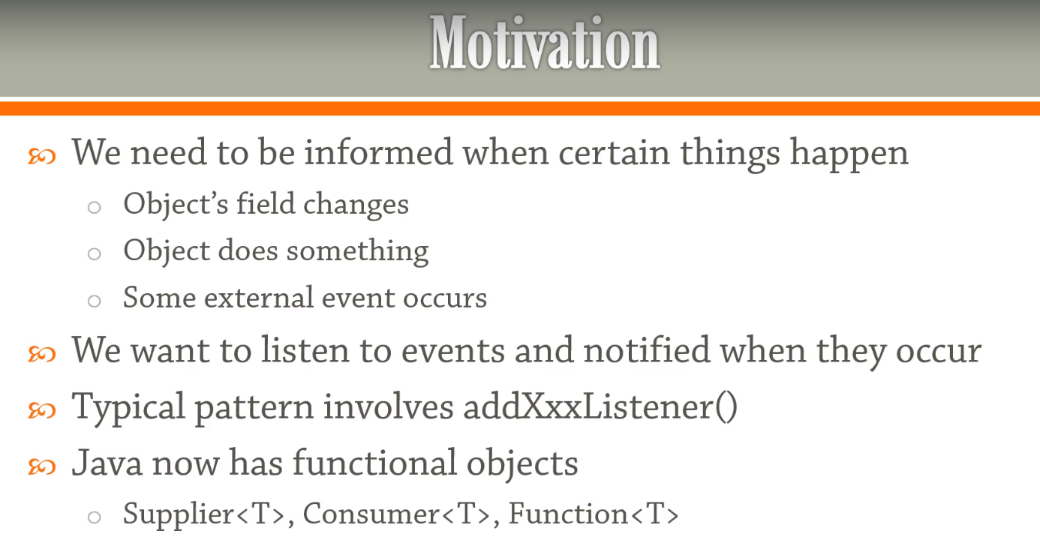

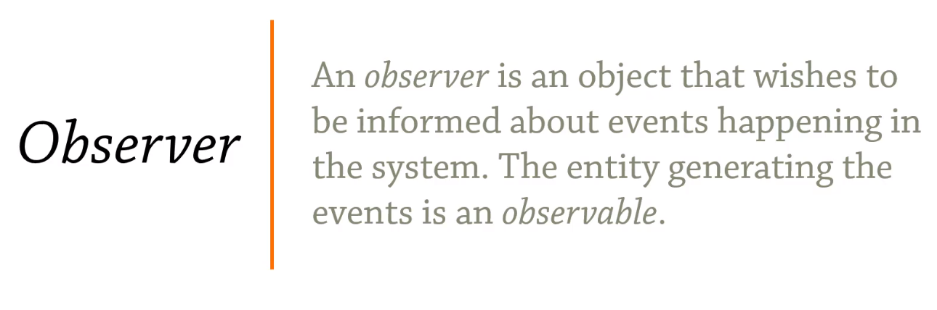

Example scenario: Assume we have a Person class with Age property. We need to be informed whenever someone sets the Person age.

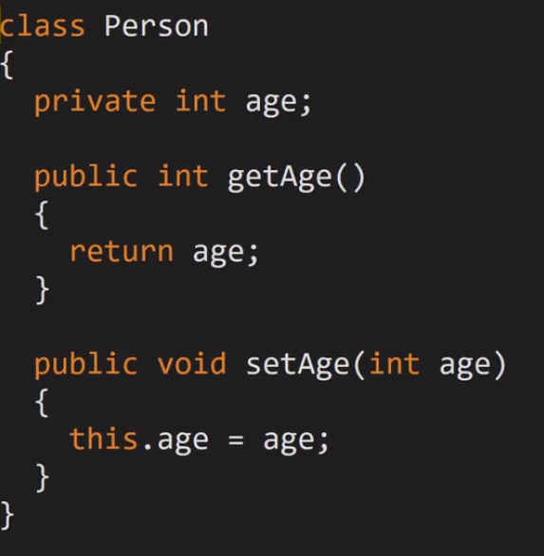

We introduce PropertyChangedEventArgd which has the Object on which property change occurred , the name of the property and the new value .

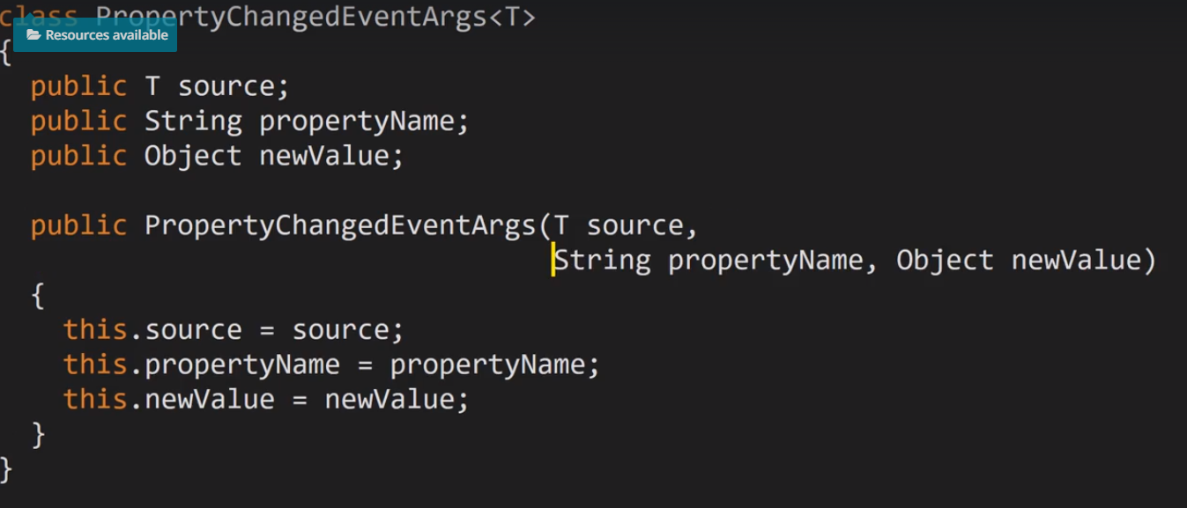

Observer is the interface to be implemented by anyone interested in observing an object of type T.

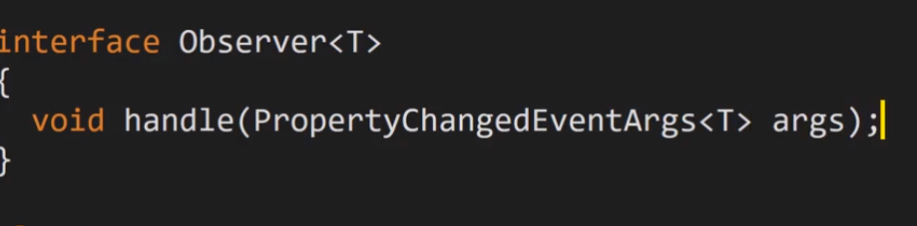

Define your on handle method and that get executed when someone changes the property.

Observable contains the list of Observers.

* The approach of Observer/Observable is not good so the Event approach is preferred.

We can have the Event and a Subscription to the Event.

Each Consumer can be notified with a fire() event.

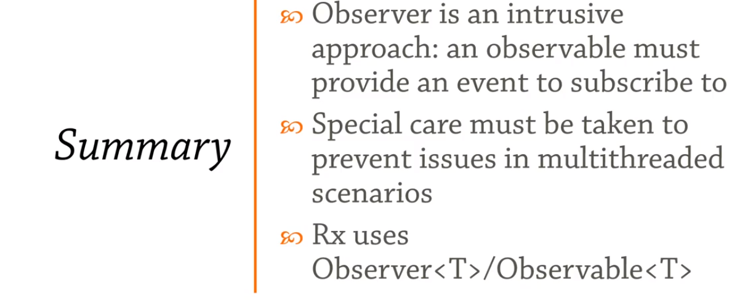

### Strategy:

* Allows to partially design the behaviour of the system and augment it later on at runtime.
* Encapsulates an algorithm inside a class.

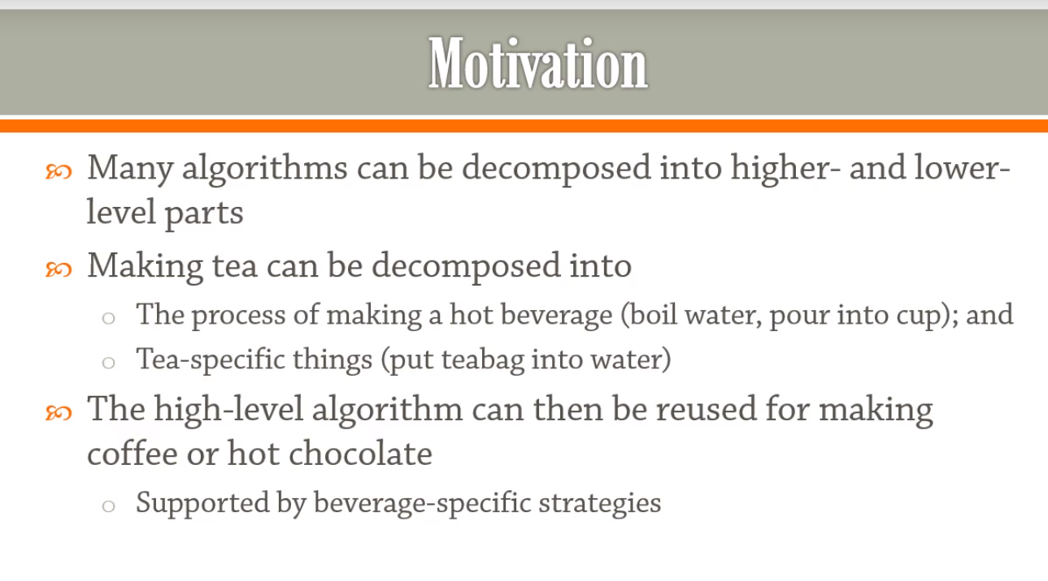

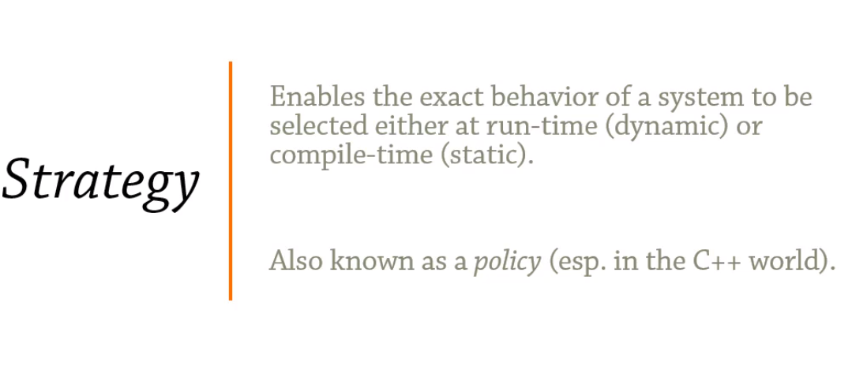

* Encapsulates an algorithm inside a class

#### Dynamic Strategy:

The below scenario defines the dynamic strategy. Let’s think of scenario where we can output using either ‘HTML’ or ‘Markdown’. So here we define the strategy to list the elements.

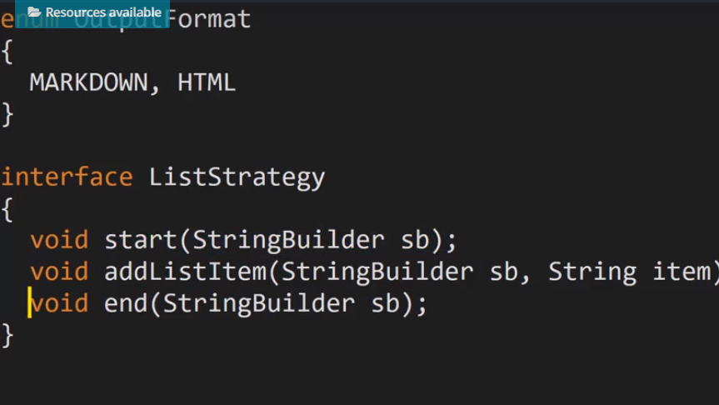

* For Markdown we don’t need start and end , so we define it as default.
* The strategy can be switched during runtime.

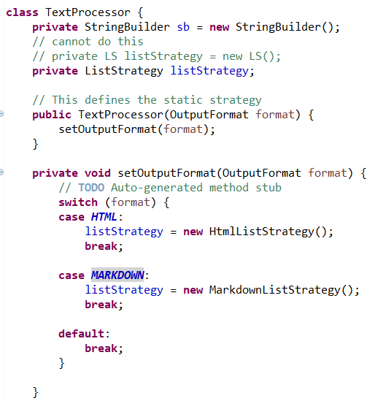

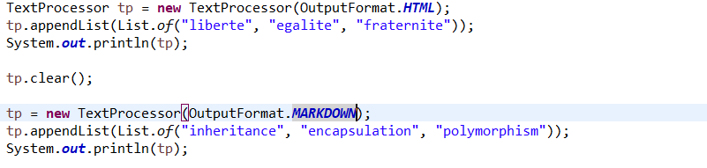

#### Static Strategy:

We need to use the same strategy as the one used during compile time. This we will enforce with the type being declared during initialization.

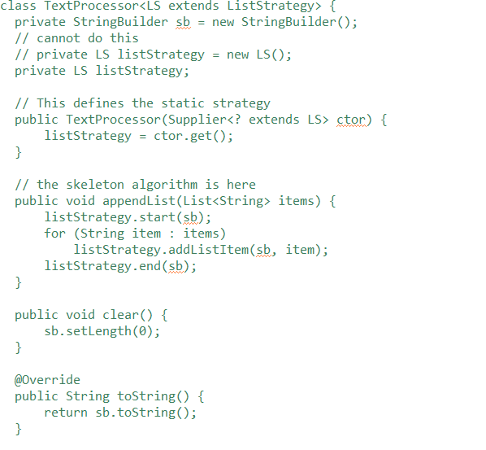

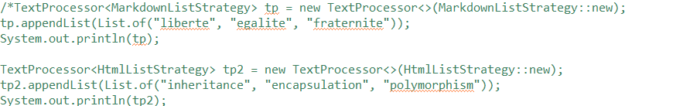

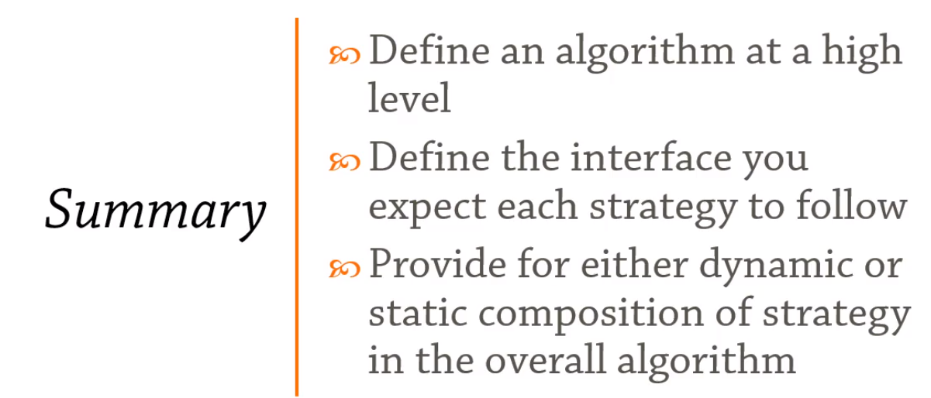

### Template:

* Difference between strategy is instead of plugging in an object we expect a sub class to provide the implementation.

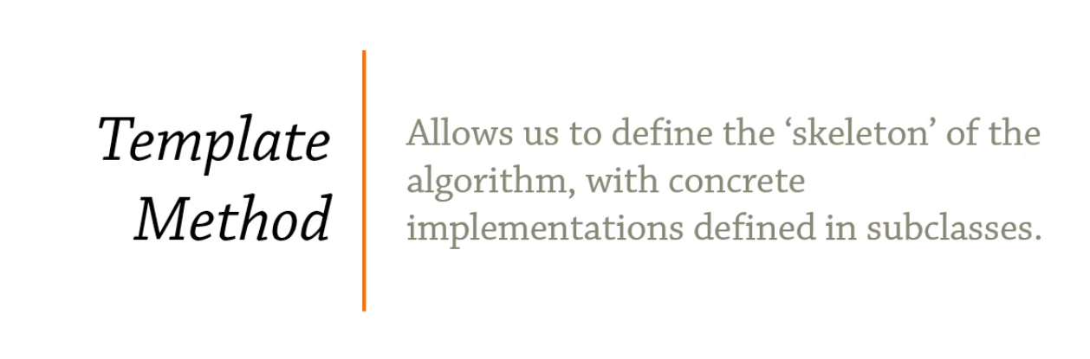

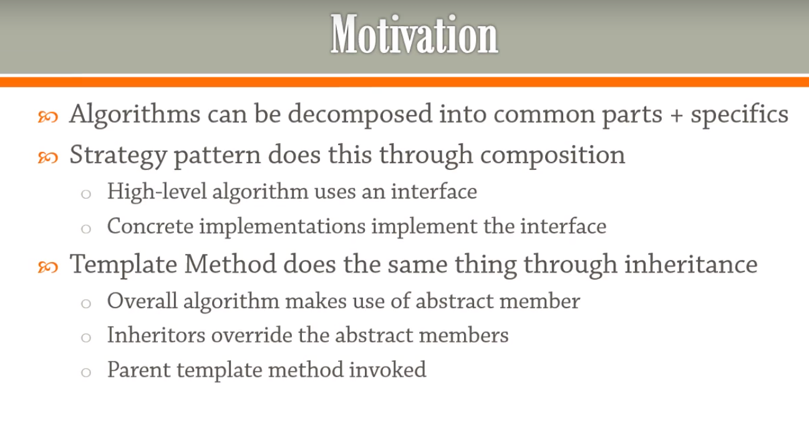

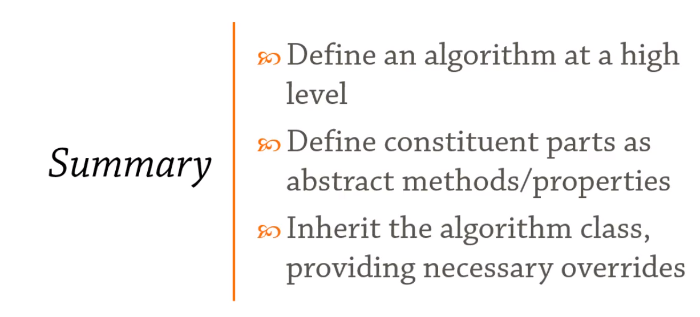

* Defer the exact steps of an algorithm to a subclass
* Define a base class(abstract class) ,define the skelton algorithm as abstract and let the implementation class implements the same. Ex: Game & Chess.
* Check the coding exercise.
* 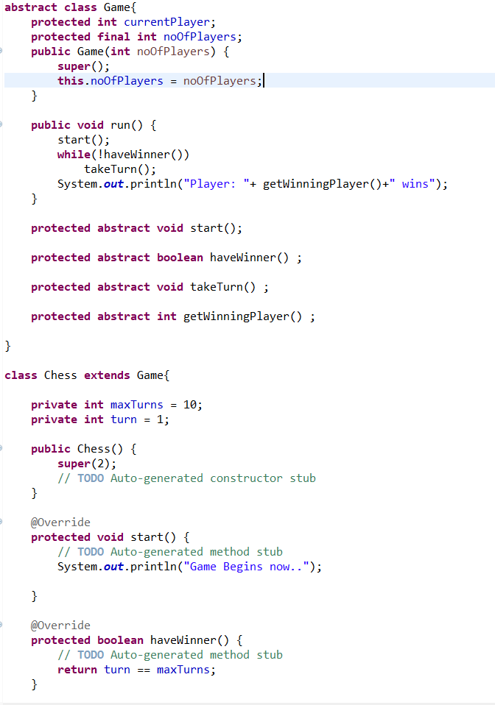

### Visitor:

* Defines a new operation to a class without any change.
* Add extra behaviour not to just the class but the entire hierarchy of classes.

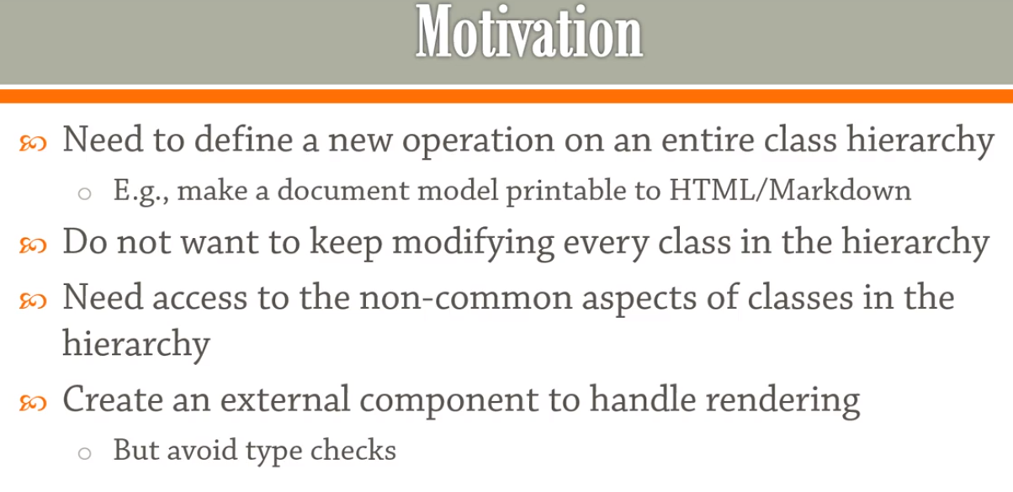

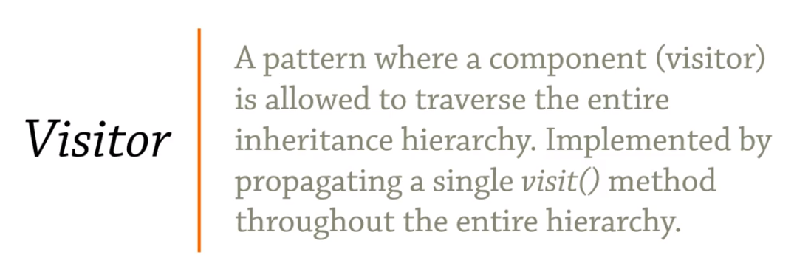

#### Intrusive Visitor:

* Consider the below example where we are introducing expressions. Now we need to have a functionality to print the expression
* By intrusive, we mean to jump into all the classes we have written and tested and change the code to add new functionality. This breaks the OCP.
* Add the print method in abstract class.

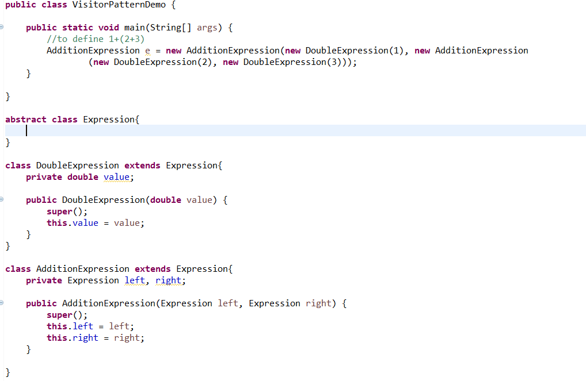

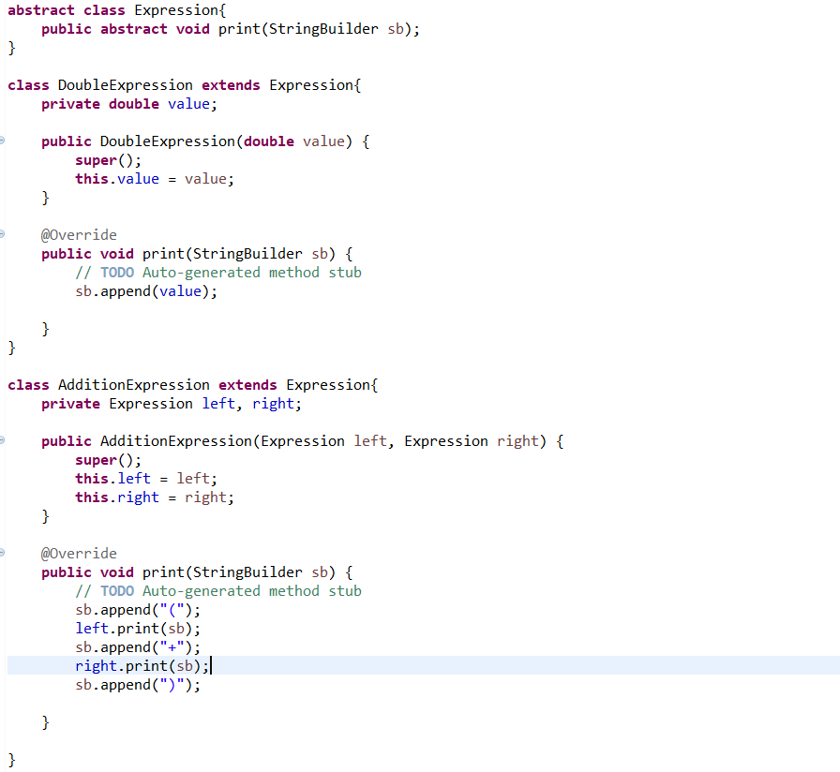

As printing is a separate concern, we need to delegate the same to different class. So the above approach is not good and we have to follow different approach as follows.

#### Reflective Visitor:

In reflective visitor approach, for the above scenario introduce a new class responsible for printing the expression. But the issue with this approach is that we are going to use Reflection in this case.

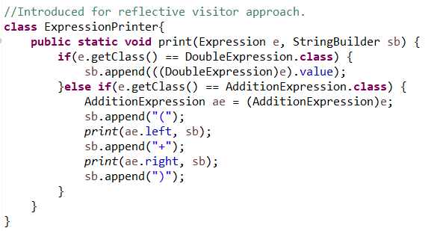

#### Classic Visitor (Double Dispatch):

This approach is the classic implementation of visitor pattern. Here we will introduce a visit () method in all the hierarchical classes so that all the classes are visited and will make sure no implementation is missed accidentally by implementing through interface.

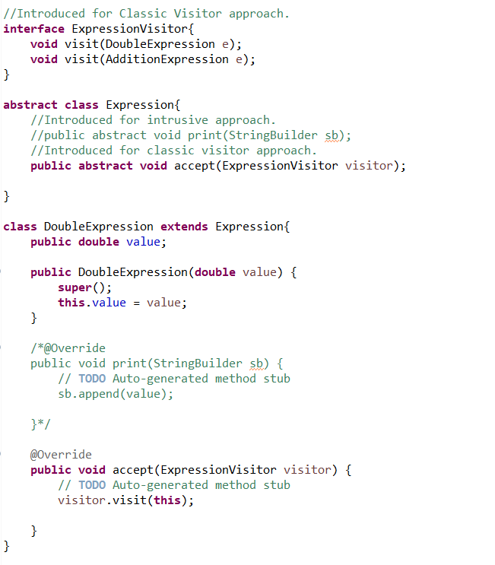

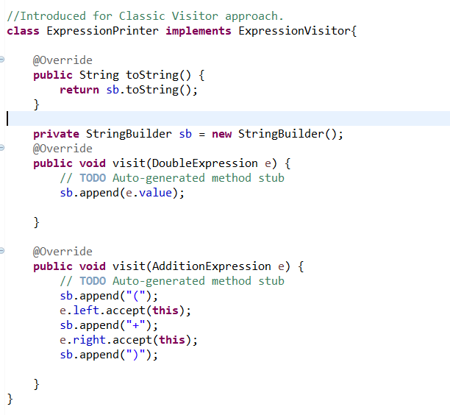

Suppose if we want to introduce a new calculator for expression like printer we need to write ExpressionCalculator and perform the following:

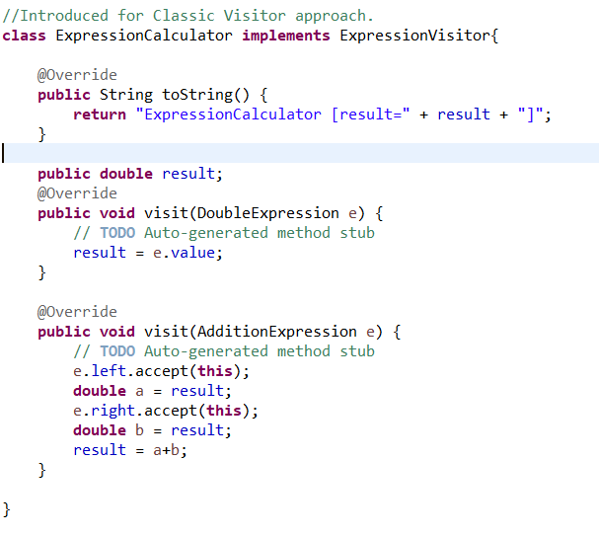

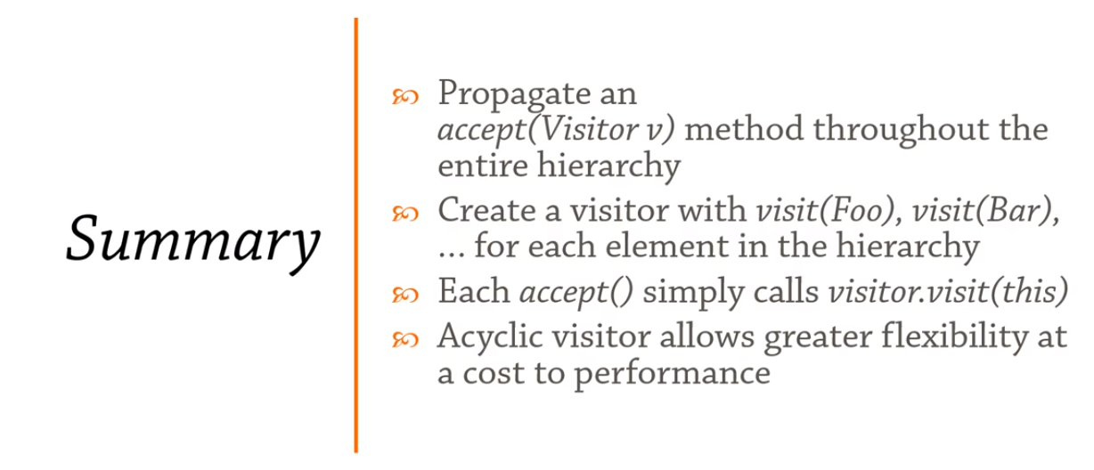

### Mediator:

* Defines simplified communication between classes

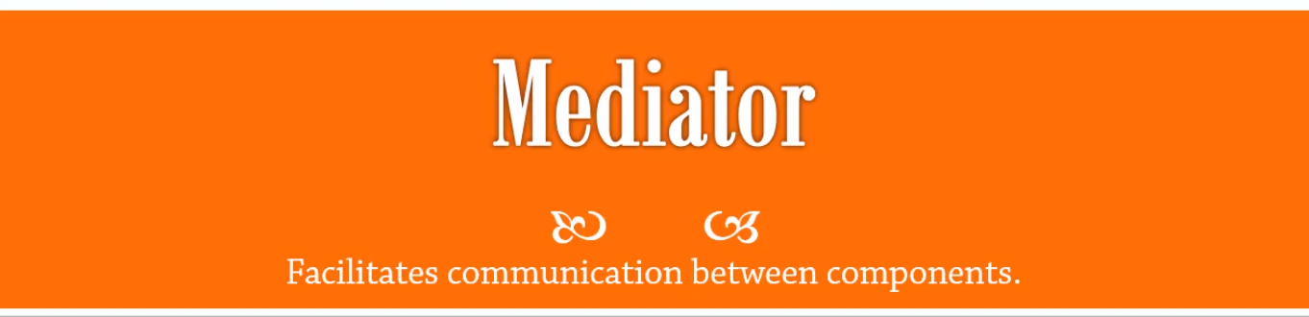

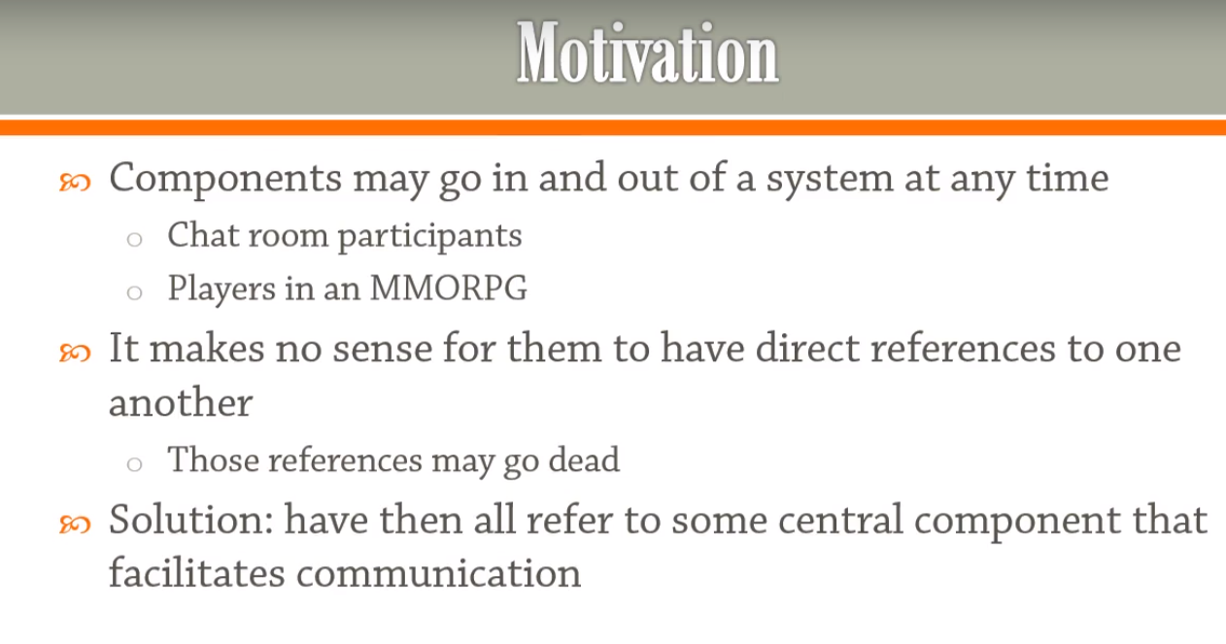

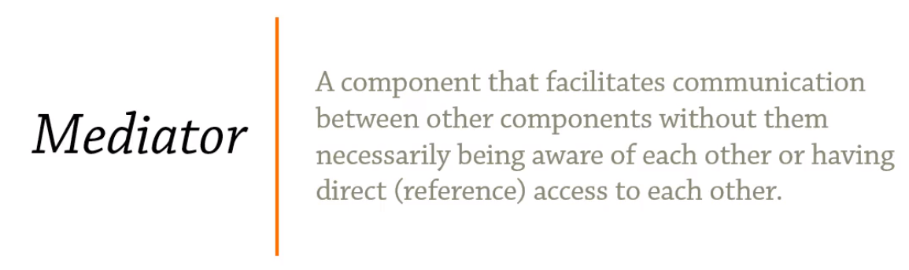

* This can be demonstrated with an example of ChatRoom, where the participants may go in and out at any time.

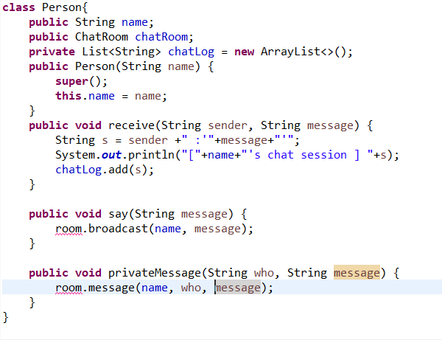

Let’s have the Person class as above with say(broadcast to a group),private message(message to individuals), receive(receive messages) methods.

In the below example, the chatroom acts as the mediator.

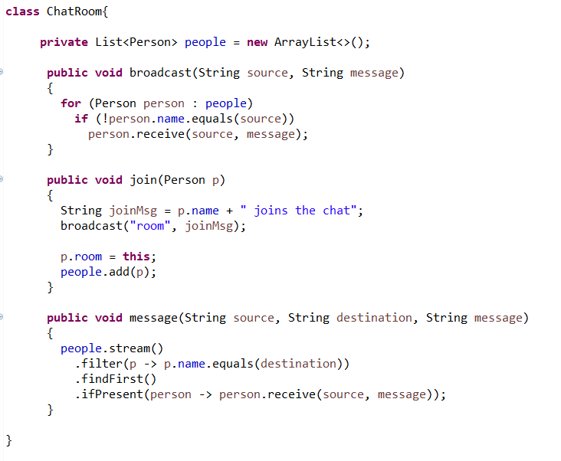

Person never referenced another person directly, but using the name, through the chat room(mediator) the persons communicate each other.

#### Reactive Extensions Event Broker:

Scenario: Football match , we have player running around the field and coach who want to congratulate the player.

EventBroker will be the mediator here.

